13th Sunday after Pentecost
Sunday, August 23, 2026
8:00 am

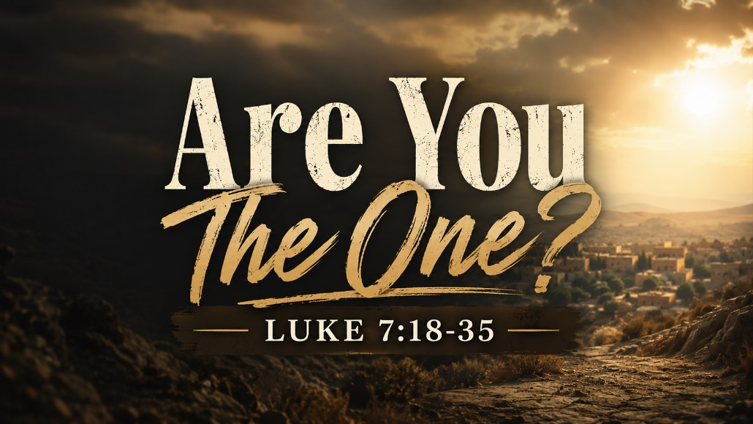

147 West Forest Street Clyde, Ohio
Prelude, Bell & Announcements
Confession & Forgiveness Pg. 94
P: In the name of the Father, and of the ☩ Son, and of the Holy Spirit.
C: Amen.
P: God of all mercy and consolation, come to the help of your people, turning us from our sin to live for you alone. Give us the power of your Holy Spirit that we may confess our sin, receive your forgiveness and grow into the fullness of Jesus Christ, our Savior and Lord.
C: Amen.
P: Let us confess our sin in the presence of God and of one another.
P: Most merciful God,
C: We confess that we are captive to sin and cannot free ourselves. We have sinned against you in thought, word, and deed, by what we have done and by what we have left undone. We have not loved you with our whole heart; we have not loved our neighbors as ourselves. For the sake of your Son, Jesus Christ, have mercy on us. Forgive us, renew us, and lead us, so that we may delight in your will and walk in your ways, to the glory of your holy name. Amen.
P: God who is rich in mercy, loved us even when we were dead in sin, and made us alive together with Christ. By grace you have been saved. In the name of Jesus Christ, the entirety of your sins are forgiven. Almighty God strengthen you with power through the Holy Spirit, that Christ may live in your hearts through faith.
C: Amen.
Hymn “Abide with Me” 5vs #629

The Apostolic Greeting Pg. 147
P: The grace of our Lord Jesus Christ, the love of God, and the communion of the Holy Spirit be with you all.
C: And also with you.
The Kyrie Pg. 147
P: In peace, let us pray to the Lord.
C: Lord, have mercy.
P: For the peace from above, and for our salvation, let us pray to the Lord.
C: Lord, have mercy.
P: For the peace of the whole world, for the well-being of the church of God, and for the unity of all, let us pray to the Lord.
C: Lord, have mercy.
P: For this holy house, and for all who offer here their worship and praise, let us pray to the Lord.
C: Lord, have mercy.
P: Help, save, comfort, and defend us gracious Lord.
C: Amen.
The Hymn of Praise Pg. 149
P: This is the feast of victory for our God. Alleluia.
Worthy is Christ, the Lamb who was slain, whose blood set us free to be people of God. Power and riches and wisdom and strength, and honor and blessing and glory are his.
This is the feast of victory for our God. Alleluia.
Sing with all the people of God and join in the hymn of all creation: Blessing and honor and glory and might be to God and the Lamb forever. Amen.
This is the feast of victory for our God, for the Lamb who was slain has begun his reign. Alleluia. Alleluia.
The Prayer of the Day
Care for your Church, O Lord, with perpetual mercy. Since we totter and are sure to fall without your grace, remove what will harm us and arrange what will make us whole. Grant this, we pray, through Jesus Christ, your Son, our Lord, who lives and reigns with you and the Holy Spirit, one God, now and forever. Amen.
The First Reading: Isaiah 42:1-9
¹Behold my servant, whom I uphold, my chosen, in whom my soul delights; I have put my Spirit upon him; he will bring forth justice to the nations. ²He will not cry aloud or lift up his voice, or make it heard in the street; ³ a bruised reed he will not break, and a faintly burning wick he will not quench; he will faithfully bring forth justice. ⁴He will not grow faint or be discouraged till he has established justice in the earth; and the coastlands wait for his law. ⁵Thus says God, the Lord, who created the heavens and stretched them out, who spread out the earth and what comes from it, who gives breath to the people on it and spirit to those who walk in it: ⁶“I am the Lord; I have called you in righteousness; I will take you by the hand and keep you; I will give you as a covenant for the people, a light for the nations, ⁷ to open the eyes that are blind, to bring out the prisoners from the dungeon, from the prison those who sit in darkness. ⁸I am the Lord; that is my name; my glory I give to no other, nor my praise to carved idols. ⁹Behold, the former things have come to pass, and new things I now declare; before they spring forth I tell you of them.”
L: The Word of the Lord.
C: Thanks be to God.

Psalm 130
¹Out of the depths I cry to you, O Lord!
²O Lord, hear my voice! Let your ears be attentive to the voice of my pleas for mercy!

³If you, O Lord, should mark iniquities, O Lord, who could stand?
⁴But with you there is forgiveness, that you may be feared.

⁵I wait for the Lord, my soul waits, and in his word I hope;
⁶my soul waits for the Lord more than watchmen for the morning, more than watchmen for the morning.

⁷O Israel, hope in the Lord! For with the Lord there is steadfast love, and with him is plentiful redemption.
⁸And he will redeem Israel from all his iniquities.
L: Here ends the reading of the Psalm.
C: Thanks be to God.
The Second Reading: 1 Peter 1:8-13
⁸Though you have not seen him, you love him. Though you do not now see him, you believe in him and rejoice with joy that is inexpressible and filled with glory, ⁹obtaining the outcome of your faith, the salvation of your souls. ¹⁰Concerning this salvation, the prophets who prophesied about the grace that was to be yours searched and inquired carefully, ¹¹inquiring what person or time the Spirit of Christ in them was indicating when he predicted the sufferings of Christ and the subsequent glories. ¹²It was revealed to them that they were serving not themselves but you, in the things that have now been announced to you through those who preached the good news to you by the Holy Spirit sent from heaven, things into which angels long to look. Called to Be Holy ¹³Therefore, preparing your minds for action, and being sober-minded, set your hope fully on the grace that will be brought to you at the revelation of Jesus Christ.
L: The Word of the Lord.
C: Thanks be to God.
The Gospel Acclamation Pg. 151
Alleluia. Lord, to whom shall we go? You have the words of eternal life. Alleluia.
P: The Holy Gospel according to St. Luke, the 7th chapter.
C: Glory to You, O Lord.
The Gospel: Luke 7:18-35
¹⁸The disciples of John reported all these things to him. And John, ¹⁹calling two of his disciples to him, sent them to the Lord, saying, “Are you the one who is to come, or shall we look for another?” ²⁰And when the men had come to him, they said, “John the Baptist has sent us to you, saying, ‘Are you the one who is to come, or shall we look for another?’” ²¹In that hour he healed many people of diseases and plagues and evil spirits, and on many who were blind he bestowed sight. ²²And he answered them, “Go and tell John what you have seen and heard: the blind receive their sight, the lame walk, lepers are cleansed, and the deaf hear, the dead are raised up, the poor have good news preached to them. ²³And blessed is the one who is not offended by me.” ²⁴When John’s messengers had gone, Jesus began to speak to the crowds concerning John: “What did you go out into the wilderness to see? A reed shaken by the wind? ²⁵What then did you go out to see? A man dressed in soft clothing? Behold, those who are dressed in splendid clothing and live in luxury are in kings’ courts. ²⁶What then did you go out to see? A prophet? Yes, I tell you, and more than a prophet. ²⁷This is he of whom it is written, “‘Behold, I send my messenger before your face, who will prepare your way before you.’ ²⁸ I tell you, among those born of women none is greater than John. Yet the one who is least in the kingdom of God is greater than he.” ²⁹(When all the people heard this, and the tax collectors too, they declared God just, having been baptized with the baptism of John, ³⁰but the Pharisees and the lawyers rejected the purpose of God for themselves, not having been baptized by him.) ³¹ “To what then shall I compare the people of this generation, and what are they like? ³²They are like children sitting in the marketplace and calling to one another, “‘We played the flute for you, and you did not dance; we sang a dirge, and you did not weep.’ ³³ For John the Baptist has come eating no bread and drinking no wine, and you say, ‘He has a demon.’ ³⁴The Son of Man has come eating and drinking, and you say, ‘Look at him! A glutton and a drunkard, a friend of tax collectors and sinners!’ ³⁵Yet wisdom is justified by all her children.”
P: Gospel of the Lord
C: Praise to You, O Christ.
Sermon:
“Are You the One?”
Luke 7:18-35
Pastor Sam Dagg
The Hymn “ Here I am Lord” 3vs #574


Prayers of Intercession
Vickie Aldrich
Gwendolyn Baughn
Molly Binder
Michelle Borodkin
Courtney Bouyack
Tim Cooper
Toni Dagg
Crew Dearth
Sharon Duskin
Becky Karr
Kris Larkins
Denise McCubbin
Matt Pumphrey
Maverick Salazar
Lindsay Sooy
Larry Sumner
Conner Whaley
Sandy Wott
Jim Shull
Matt Woodland
Sandy Gray
Deacon Norbert
THE APOSTLES’ CREED (back cover of the hymnal)
The Peace of the Lord Pg. 152
P: The peace of the Lord be with you.
C: And also, with you.
The Passing of the Peace
The Offering
The Offering Prayer
Blessed are you, O God, maker of all things. Through your goodness you have blessed us with these gifts: our possessions. Use us, and what we have gathered, in feeding the world with your love, through the one who gave himself for us, Jesus Christ, our Savior and Lord. Amen.
The Great Thanksgiving Pg. 152
P: The Lord be with you.
C: And also, with you.
P: Lift up your hearts.
C: We lift them to the Lord.
P: Let us give thanks to the Lord our God.
C: It is right to give our thanks and praise.
The Proper Preface
P: It is indeed right, our duty and our joy, that we should at all times and in all places give thanks and praise to You, almighty and merciful God. You reveal Your glory as the glory of the Father, the Son, and the Holy Spirit; equal in majesty, undivided in splendor, one Lord, one God, ever to be adored in Your eternal glory. And so, with all the choirs of angels, with the church on earth and the hosts of heaven, we praise Your name and join their unending hymn:
C: Holy, holy, holy Lord,
Lord God of power and might,
heav’n and earth are full of your glory.
Hosanna in the highest.
Blessed is he who comes in the name of the Lord.
Hosanna in the highest.
The Words of Institution
The Lord’s Prayer Pg. 154
P: Gathered into one by the Holy Spirit, let us pray as Jesus taught us.
C: Our Father, Who art in heaven, hallowed be Thy name, Thy kingdom come, Thy will be done, on earth as it is in heaven. Give us this day our daily bread; and forgive us our trespasses, as we forgive those who trespass against us; and lead us not into temptation, but deliver us from evil. For Thine is the kingdom, and the power, and the glory, forever and ever. Amen.
Invitation to Communion Pg. 154 P: Come to the banquet, for all is now ready.
Holy Communion
All baptized believers in Jesus Christ as Lord are invited to receive communion today. Please follow the pastor’s instructions.
The Post Communion Blessing
P: The body and blood of our Lord Jesus Christ strengthen you and keep you in His grace.
C: Amen.
Prayer After Communion
P: Let us pray.
C: O God, we give You thanks that You have set before us this feast, the body and blood of Your Son. By Your Spirit strengthen us to serve all in need and to give ourselves away as bread for the hungry, through Jesus Christ our Lord. Amen.
The Hymn “God Be With You Till We Meet Again”3vs #536
The Benediction
P: May the Lord bless you and keep you;
the Lord make his face shine on you and be gracious to you;
the Lord turn his face toward you and give you peace.
In the name of the Father,
and of the ☩ Son,
and of the Holy Spirit.
C: Amen.
The Dismissal
P: GO IN PEACE. SERVE THE LORD!
C: Thanks be to God.
The Postlude

Lutheran Disaster Response Flood Buckets
You’ll notice five-gallon buckets at the front of the church. We’ve invited our whole congregation to help assemble flood relief buckets for Lutheran Disaster Response.
These buckets are to be filled with cleaning supplies and given to families after floods, hurricanes and other natural disasters. It’s a simple practical way for our church family to serve people in their time of need and show the love of Christ. If you have buckets, please return them by August 30th. Thank you!
* * * * * * * * * * * * * * * * * * * * * * * * * * * * * * * * * * * * * * * * * *


* * * * * * * * * * * * * * * * * * * * * * * * * * * * * * * * * * * * * * * * * *
ALTAR FLOWERS

The altar flowers are given to the Glory of God by Tammy Baker in honor of her sister Kim’s birthday August 21st and her son Riley’s August 28th.
* * * * * * * * * * * * * * * * * * * * * * * * * * * * * * * * * * * * * * * * * *
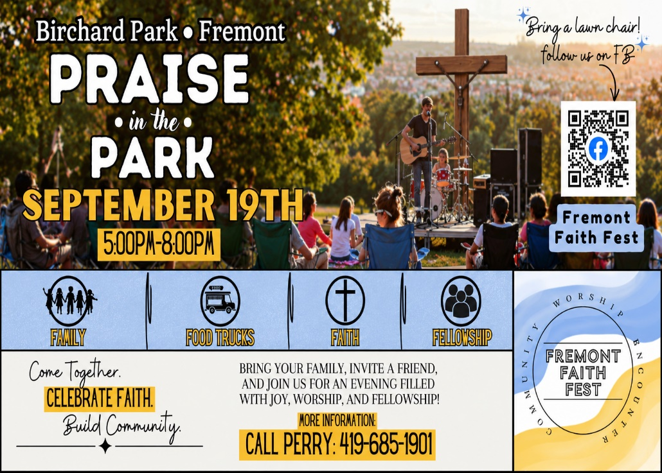
* * * * * * * * * * * * * * * * * * * * * * * * * * * * * * * * * * * * * * * * * *



August 2026
Sunday  23 | 8:00 am ~ Worship  10:30 am ~ Worship  3:00 pm ~ Bunco
Monday  24 | 6:30 pm ~ Co-Ed Bible Study
Tuesday  25 | 6:30 pm ~ Men’s Bible Study
Wednesday 26 | 9:00 am ~ Quilt Ministry  6:00 pm ~ Women’s Bible Study
Thursday  27 | 7:00 pm ~ Al-Anon Meeting  8:00 pm ~ AA Meeting
Friday
28
Saturday  29 | 8:00 am ~ Men’s Bible Study  5:00 pm ~ Worship
Sunday  30 | 8:00 am ~ Worship  10:30 am ~ Worship

August 15-16 Attendance: 183

8:00 am Service
COMPUTER TECH: Ashley Reed
READER: Jane Hilton
USHERS: Tim Billings
Duane Kimmet
Jeanie Kimmet

* * * * * * * * * * * * * * * * * * * * * * * * * * * * * * * * * * * * * * * * * *
Church Office Phone: 419-547-9225
Jamie Farrar Phone: 419-603-6731
sec@stpaulclyde.org
Pastor Samuel Dagg Phone: 567-342-2137
pastor@stpaulclyde.org
Matt Woodland ~ Council President Phone: 419-603-0567
prez@stpaulclyde.org
Jim Shull ~ Treasurer Phone: 419-355-6499
treas@stpaulclyde.org
Brian Farrar ~ P & W Leader Phone: 419-271-3085
pwl@stpaulclyde.org
Ashley Reed ~ Assistant Secretary asst.sec@stpaulclyde.org
Sherry Bouyack ~ Clerical Secretary fisec@stpaulclyde.org
Organist
Mary Ellen Wollenslegel
* * * * * * * * * * * * * * * * * * * * * * * * * * * * * * * * * * * * *

Sermon Notes

