Seventh Sunday after Pentecost
Sunday, July 12, 2026
8:00 am

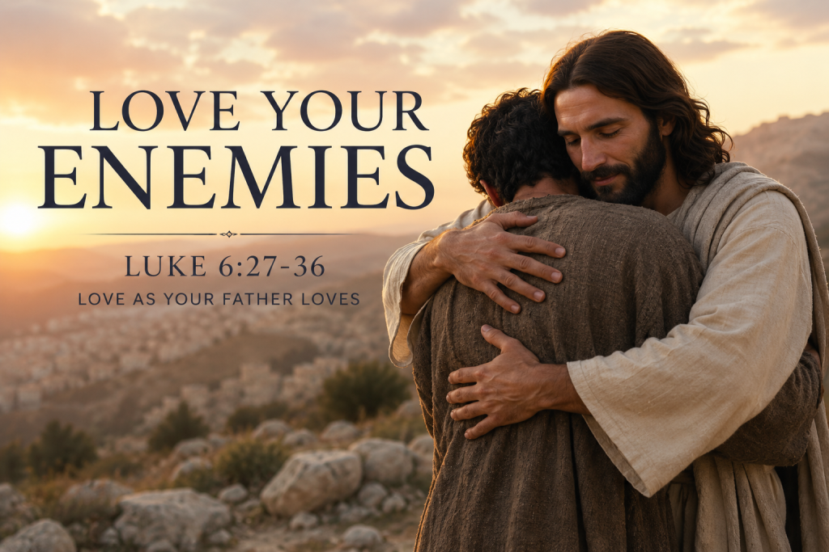

147 West Forest Street Clyde, Ohio
Prelude, Bell & Announcements
Confession & Forgiveness Pg. 94
P: In the name of the Father, and of the ☩ Son, and of the Holy Spirit.
C: Amen.
P: God of all mercy and consolation, come to the help of your people, turning us from our sin to live for you alone. Give us the power of your Holy Spirit that we may confess our sin, receive your forgiveness and grow into the fullness of Jesus Christ, our Savior and Lord.
C: Amen.
P: Let us confess our sin in the presence of God and of one another.
P: Most merciful God,
C: We confess that we are captive to sin and cannot free ourselves. We have sinned against you in thought, word, and deed, by what we have done and by what we have left undone. We have not loved you with our whole heart; we have not loved our neighbors as ourselves. For the sake of your Son, Jesus Christ, have mercy on us. Forgive us, renew us, and lead us, so that we may delight in your will and walk in your ways, to the glory of your holy name. Amen.
P: God who is rich in mercy, loved us even when we were dead in sin, and made us alive together with Christ. By grace you have been saved. In the name of Jesus Christ, the entirety of your sins are forgiven. Almighty God strengthen you with power through the Holy Spirit, that Christ may live in your hearts through faith.
C: Amen.
Hymn “Love Divine All Love Excelling” #631
The Apostolic Greeting Pg. 147
P: The grace of our Lord Jesus Christ, the love of God, and the communion of the Holy Spirit be with you all.
C: And also with you.
The Kyrie Pg. 147
P: In peace, let us pray to the Lord.
C: Lord, have mercy.
P: For the peace from above, and for our salvation, let us pray to the Lord.
C: Lord, have mercy.
P: For the peace of the whole world, for the well-being of the church of God, and for the unity of all, let us pray to the Lord.
C: Lord, have mercy.
P: For this holy house, and for all who offer here their worship and praise, let us pray to the Lord.
C: Lord, have mercy.
P: Help, save, comfort, and defend us gracious Lord.
C: Amen.
The Hymn of Praise Pg. 149
P: This is the feast of victory for our God. Alleluia.
Worthy is Christ, the Lamb who was slain, whose blood set us free to be people of God. Power and riches and wisdom and strength, and honor and blessing and glory are his.
This is the feast of victory for our God. Alleluia.
Sing with all the people of God and join in the hymn of all creation: Blessing and honor and glory and might be to God and the Lamb forever. Amen.
This is the feast of victory for our God, for the Lamb who was slain has begun his reign. Alleluia. Alleluia.
The Prayer of the Day
Almighty and everlasting God, you have given us grace to make the confession of a true faith. We acknowledge your glorious eternal Trinity, and we adore the unity of your majestic work. Defend us by this faith from all adversity and opposition to your way; through Jesus Christ, your Son, our Lord, who lives and reigns with you and the Holy Spirit, one God, now and forever. Amen.
The First Reading: Isaiah 43:16–21
¹⁶Thus says the Lord, who makes a way in the sea, a path in the mighty waters, ¹⁷who brings forth chariot and horse, army and warrior; they lie down, they cannot rise, they are extinguished, quenched like a wick: ¹⁸“Remember not the former things, nor consider the things of old. ¹⁹Behold, I am doing a new thing; now it springs forth, do you not perceive it? I will make a way in the wilderness and rivers in the desert. ²⁰The wild beasts will honor me, the jackals and the ostriches, for I give water in the wilderness, rivers in the desert, to give drink to my chosen people, ²¹the people whom I formed for myself that they might declare my praise.
L: The Word of the Lord.
C: Thanks be to God.
Psalm 126
¹ When the Lord restored the fortunes of Zion, we were like those who dream.
² Then our mouth was filled with laughter, and our tongue with shouts of joy; then they said among the nations, “The Lord has done great things for them.”
³ The Lord has done great things for us; we are glad.
⁴ Restore our fortunes, O Lord, like streams in the Negeb!
⁵ Those who sow in tears shall reap with shouts of joy!
⁶He who goes out weeping, bearing the seed for sowing, shall come home with shouts of joy, bringing his sheaves with him.
L: Here ends the reading of the Psalm.
C: Thanks be to God.
The Second Reading: 2 Corinthians 5:14–21
¹⁴For the love of Christ controls us, because we have concluded this: that one has died for all, therefore all have died; ¹⁵and he died for all, that those who live might no longer live for themselves but for him who for their sake died and was raised. ¹⁶From now on, therefore, we regard no one according to the flesh. Even though we once regarded Christ according to the flesh, we regard him thus no longer. ¹⁷Therefore, if anyone is in Christ, he is a new creation. The old has passed away; behold, the new has come. ¹⁸All this is from God, who through Christ reconciled us to himself and gave us the ministry of reconciliation; ¹⁹that is, in Christ God was reconciling the world to himself, not counting their trespasses against them, and entrusting to us the message of reconciliation. ²⁰Therefore, we are ambassadors for Christ, God making his appeal through us. We implore you on behalf of Christ, be reconciled to God. ²¹For our sake he made him to be sin who knew no sin, so that in him we might become the righteousness of God.
L: The Word of the Lord.
C: Thanks be to God.
The Gospel Acclamation Pg. 151
Alleluia. Lord, to whom shall we go? You have the words of eternal life. Alleluia.
P: The Holy Gospel according to St. Luke, the 6th chapter.
C: Glory to You, O Lord.

The Gospel: Luke 6:27-36
²⁷“But I say to you who hear, Love your enemies, do good to those who hate you, ²⁸bless those who curse you, pray for those who abuse you. ²⁹To one who strikes you on the cheek, offer the other also, and from one who takes away your cloak do not withhold your tunic either. ³⁰Give to everyone who begs from you, and from one who takes away your goods do not demand them back. ³¹And as you wish that others would do to you, do so to them. ³²“If you love those who love you, what benefit is that to you? For even sinners love those who love them. ³³And if you do good to those who do good to you, what benefit is that to you? For even sinners do the same. ³⁴And if you lend to those from whom you expect to receive, what credit is that to you? Even sinners lend to sinners, to get back the same amount. ³⁵But love your enemies, and do good, and lend, expecting nothing in return, and your reward will be great, and you will be sons of the Most High, for he is kind to the ungrateful and the evil. ³⁶Be merciful, even as your Father is merciful.
P: The Gospel of the Lord.
C: Praise to You, O Christ.
Sermon:
“Love Your Enemies”
Luke 6:27-36
Pastor Sam Dagg
The Hymn “Blest Be the Tie That Binds” #656


Prayers of Intercession
Vickie Aldrich
Gwendolyn Baughn
Molly Binder
Michelle Borodkin
Courtney Bouyack
Tim Cooper
Toni Dagg
Crew Dearth
Sharon Duskin
Becky Karr
Kris Larkins
Denise McCubbin
Karen Nimms
Matt Pumphrey
Maverick Salazar
Lindsay Sooy
Larry Sumner
Conner Whaley
Sandy Wott
Katie Spence
Millie Burr
Sharon McGlohn
THE APOSTLES’ CREED (back cover of the hymnal)
The Peace of the Lord Pg. 152
P: The peace of the Lord be with you.
C: And also, with you.
The Passing of the Peace
The Offering
The Offering Prayer
Blessed are you, O God, maker of all things. Through your goodness you have blessed us with these gifts: our possessions. Use us, and what we have gathered, in feeding the world with your love, through the one who gave himself for us, Jesus Christ, our Savior and Lord. Amen.
The Great Thanksgiving Pg. 152
P: The Lord be with you.
C: And also, with you.
P: Lift up your hearts.
C: We lift them to the Lord.
P: Let us give thanks to the Lord our God.
C: It is right to give our thanks and praise.
The Proper Preface
P: It is indeed right, our duty and our joy, that we should at all times and in all places give thanks and praise to You, almighty and merciful God. You reveal Your glory as the glory of the Father, the Son, and the Holy Spirit; equal in majesty, undivided in splendor, one Lord, one God, ever to be adored in Your eternal glory. And so, with all the choirs of angels, with the church on earth and the hosts of heaven, we praise Your name and join their unending hymn:
C: Holy, holy, holy Lord,
Lord God of power and might,
heav’n and earth are full of your glory.
Hosanna in the highest.
Blessed is he who comes in the name of the Lord.
Hosanna in the highest.
The Words of Institution
The Lord’s Prayer Pg. 154
P: Gathered into one by the Holy Spirit, let us pray as Jesus taught us.
C: Our Father, Who art in heaven, hallowed be Thy name, Thy kingdom come, Thy will be done, on earth as it is in heaven. Give us this day our daily bread; and forgive us our trespasses, as we forgive those who trespass against us; and lead us not into temptation, but deliver us from evil. For Thine is the kingdom, and the power, and the glory, forever and ever. Amen.
Invitation to Communion Pg. 154 P: Come to the banquet, for all is now ready.
Holy Communion
All baptized believers in Jesus Christ as Lord are invited to receive communion today. Please follow the directions of the ushers. Children who have not yet received their first communion are also invited to come forward, to receive a blessing.
The Post Communion Blessing
P: The body and blood of our Lord Jesus Christ strengthen you and keep you in His grace.
C: Amen.
Prayer After Communion
P: Let us pray.
C: O God, we give You thanks that You have set before us this feast, the body and blood of Your Son. By Your Spirit strengthen us to serve all in need and to give ourselves away as bread for the hungry, through Jesus Christ our Lord. Amen.
The Hymn “Joyful, Joyful We Adore Thee” #836
The Benediction
P: May the Lord bless you and keep you;
the Lord make his face shine on you and be gracious to you;
the Lord turn his face toward you and give you peace.
In the name of the Father,
and of the ☩ Son,
and of the Holy Spirit.
C: Amen.
The Dismissal
P: GO IN PEACE. SERVE THE LORD!
C: Thanks be to God.
The Postlude

* * * * * * * * * * * * * * * * * * * * * * * * * * * * * * * * * * * * * * * * * *

ALTAR FLOWERS

Given in loving memory of my parents Joe and Maxine Egger’s wedding anniversary from Deanna Turner.

* * * * * * * * * * * * * * * * * * * * * * * * * * * * * * * * * * * * * * * * * *
St. Paul will receive 4% cash back from ChristianBook.com when you “SUPPORT YOUR CHURCH” by:

- Searching St. Paul Lutheran Clyde
- Scanning the QR Code on the left
- Type RHQCYS in the search bar
in the payment section during check out. This website offers a wide variety of Christian books, Bibles, learning material and much more.
Please feel free to reach out to Ashley Reed for more information or assistance at 419-547-9225 or asst.sec@stpaulclyde.org
* * * * * * * * * * * * * * * * * * * * * * * * * * * * * * * * * * * * * * * * * * *

* * * * * * * * * * * * * * * * * * * * * * * * * * * * * * * * * * * * * * * * * * *

You will find a table in the Parish Hall filled with books that are offered free for the taking. Please visit the table and take as many as you wish.
Happy Reading!
* * * * * * * * * * * * * * * * * * * * * * * * * * * * * * * * * * * * * * * * * * *


On July 18-19, 2026 we will have Julie Barhorst from the Oesterlen Foundation here to talk about their mission. Oesterlen is a non-profit foundation that awards grants to support programs that help children and families across Ohio.
* * * * * * * * * * * * * * * * * * * * * * * * * * * * * * * * * * * * * * * * * *

If you or a loved one needs an
electric lift chair, please reach out to
Tom Thorbahn 419-366-8135 or
Kevin Larkins 567-201-3838.

* * * * * * * * * * * * * * * * * * * * * * * * * * * * * * * * * * * * * * * * * *
July 2026
Sunday  12 | 8:00 am ~ Worship  10:30 am ~ Worship  5:45 pm ~ VBS@First United Methodist Church
Monday  13 | 5:45 pm ~ VBS @ FUMC  6:30 pm ~ Co-Ed Bible Study
Tuesday  14 | 5:45 pm ~ VBS @ FUMC  6:00 pm ~ Property Board Meeting  6:30 pm ~ Men’s Bible Study  7:00 pm ~ Stewardship/Finance Board Meeting
Wednesday 15 | 5:45 pm ~ VBS @ FUMC  6:00 pm ~ Women’s Bible Study
Thursday  16 | 5:45 pm ~ VBS @ FUMC  7:00 pm ~ Council Meeting  7:00 pm ~ Al-Anon Meeting  8:00 pm ~ AA Meeting
Friday
17
Saturday  18 | 8:00 am ~ Men’s Bible Study  5:00 pm ~ Worship
Sunday  19 | 8:00 am ~ Worship  10:30 am ~ Worship
June 4-5 Attendance: 146
8:00 am Service
COMPUTER TECH: Ashley Reed
READER: Diane Hurst
USHERS: Tim Billings
Jeff Haughawout
Diane Hurst
Bob Kessler

* * * * * * * * * * * * * * * * * * * * * * * * * * * * * * * * * * * * * * * * * *
Church Office Phone: 419-547-9225
Pastor Samuel Dagg Phone: 567-342-2137
pastor@stpaulclyde.org
Matt Woodland ~ Council President Phone: 419-603-0567
prez@stpaulclyde.org
Sherry Bouyack ~ Clerical Secretary Phone: 419-547-9225
fisec@stpaulclyde.org
Jim Shull ~ Treasurer Phone: 419-355-6499
treas@stpaulclyde.org
Brian Farrar ~ P & W Leader Phone: 419-271-3085
pwl@stpaulclyde.org
Ashley Reed ~ Assistant Secretary Phone: 419-547-9225
asst.sec@stpaulclyde.org
Organist
Mary Ellen Wollenslegel
* * * * * * * * * * * * * * * * * * * * * * * * * * * * * * * * * * * * *

Sermon Notes

