Seventh Sunday After Pentecost
Sunday, July 12, 2026
10:30 am

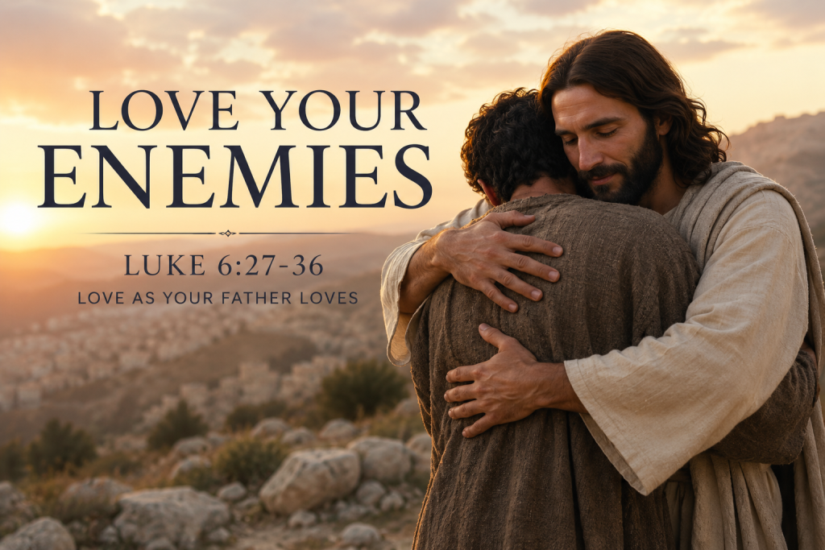

147 West Forest Street Clyde, Ohio
Prayer List
Vickie Aldrich
Gwendolyn Baughn
Molly Binder
Michelle Borodkin
Courtney Bouyack
Tim Cooper
Toni Dagg
Crew Dearth
Sharon Duskin
Becky Karr
Kris Larkins
Denise McCubbin
Karen Nimms
Matt Pumphrey
Maverick Salazar
Lindsay Sooy
Larry Sumner
Conner Whaley
Sandy Wott
Katie Spence
Millie Burr
Sharon McGlohn

* * * * * * * * * * * * * * * * * * * * * * * * * * * * * * * * * * * * * * * * * *

ALTAR FLOWERS

Given in loving memory of my parents Joe and Maxine Egger’s wedding anniversary from Deanna Turner.

* * * * * * * * * * * * * * * * * * * * * * * * * * * * * * * * * * * * * * * * * *

* * * * * * * * * * * * * * * * * * * * * * * * * * * * * * * * * * * * * * * * * * *
St. Paul will receive 4% cash back from ChristianBook.com when you “SUPPORT YOUR CHURCH” by:

- Searching St. Paul Lutheran Clyde
- Scanning the QR Code on the left
- Type RHQCYS in the search bar
in the payment section during check out. This website offers a wide variety of Christian books, Bibles, learning material and much more.
Please feel free to reach out to Ashley Reed for more information or assistance at 419-547-9225 or asst.sec@stpaulclyde.org
* * * * * * * * * * * * * * * * * * * * * * * * * * * * * * * * * * * * * * * * * * *

You will find a table in the Parish Hall filled with books that are offered free for the taking. Please visit the table and take as many as you wish.
Happy Reading!
* * * * * * * * * * * * * * * * * * * * * * * * * * * * * * * * * * * * * * * * * * *


On July 18-19, 2026 we will have Julie Barhorst from the Oesterlen Foundation here to talk about their mission. Oesterlen is a non-profit foundation that awards grants to support programs that help children and families across Ohio.
* * * * * * * * * * * * * * * * * * * * * * * * * * * * * * * * * * * * * * * * * *

If you or a loved one needs an
electric lift chair, please reach out to
Tom Thorbahn 419-366-8135 or
Kevin Larkins 567-201-3838.

* * * * * * * * * * * * * * * * * * * * * * * * * * * * * * * * * * * * * * * * * *

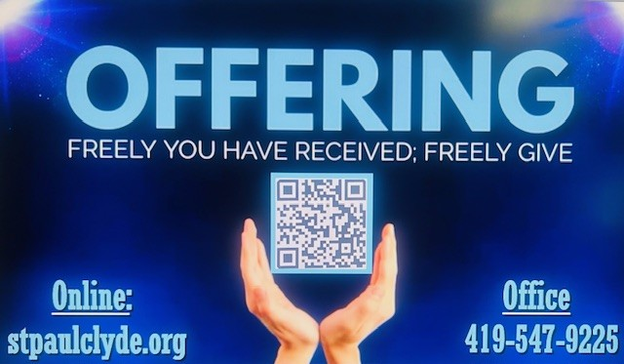

July 2026
Sunday  12 | 8:00 am ~ Worship  10:30 am ~ Worship  5:45 pm ~ VBS@First United Methodist Church
Monday  13 | 5:45 pm ~ VBS @ FUMC  6:30 pm ~ Co-Ed Bible Study
Tuesday  14 | 5:45 pm ~ VBS @ FUMC  6:00 pm ~ Property Board Meeting  6:30 pm ~ Men’s Bible Study  7:00 pm ~ Stewardship/Finance Board Meeting
Wednesday 15 | 5:45 pm ~ VBS @ FUMC  6:00 pm ~ Women’s Bible Study
Thursday  16 | 5:45 pm ~ VBS @ FUMC  7:00 pm ~ Council Meeting  7:00 pm ~ Al-Anon Meeting  8:00 pm ~ AA Meeting
Friday
17
Saturday  18 | 8:00 am ~ Men’s Bible Study  5:00 pm ~ Worship
Sunday  19 | 8:00 am ~ Worship  10:30 am ~ Worship
June 4-5 Attendance: 146
10:30 Service
ACOLYTE:
USHERS: DeAnn Krauss
Tony Paradiso
Christina Lowe
Ada Williams
COUNTERS: Theresa Elfring
Christine Potts
Brandis Stout
* * * * * * * * * * * * * * * * * * * * * * * * * * * * * * * * * * * *
Church Office Phone: 419-547-9225
Pastor Samuel Dagg Phone: 567-342-2137
pastor@stpaulclyde.org
Matt Woodland ~ Council President Phone: 419-603-0567
prez@stpaulclyde.org
Sherry Bouyack ~ Clerical Secretary Phone: 419-547-9225
fisec@stpaulclyde.org
Jim Shull ~ Treasurer Phone: 419-355-6499
treas@stpaulclyde.org
Brian Farrar ~ P & W Leader Phone: 419-271-3085
pwl@stpaulclyde.org
Ashley Reed ~ Assistant Secretary Phone: 419-547-9225 asst.sec@stpaulclyde.org


Sermon Notes

