Sixth Sunday of Easter
Sunday, May 10, 2026
8:00 am

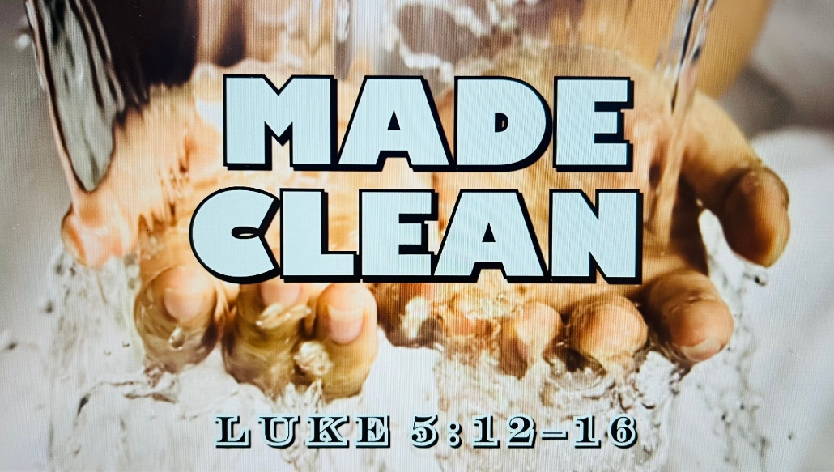

147 W. Forest Street Clyde, Ohio
Prelude, Bell & Announcements
Confession & Forgiveness Pg. 94
P: In the name of the Father, and of the ☩ Son, and of the Holy Spirit.
C: Amen.
P: God of all mercy and consolation, come to the help of your people, turning us from our sin to live for you alone. Give us the power of your Holy Spirit that we may confess our sin, receive your forgiveness and grow into the fullness of Jesus Christ, our Savior and Lord.
C: Amen.
P: Let us confess our sin in the presence of God and of one another.
P: Most merciful God,
C: we confess that we are captive to sin and cannot free ourselves. We have sinned against you in thought, word, and deed, by what we have done and by what we have left undone. We have not loved you with our whole heart; we have not loved our neighbors as ourselves. For the sake of your Son, Jesus Christ, have mercy on us. Forgive us, renew us, and lead us, so that we may delight in your will and walk in your ways, to the glory of your holy name. Amen.
P: God who is rich in mercy, loved us even when we were dead in sin, and made us alive together with Christ. By grace you have been saved. In the name of Jesus Christ, the entirety of your sins are forgiven. Almighty God strengthen you with power through the Holy Spirit, that Christ may live in your hearts through faith.
C: Amen.
Hymn “Just As I am” #592
The Apostolic Greeting Pg. 147
P: The grace of our Lord Jesus Christ, the love of God, and the communion of the Holy Spirit be with you all.
C: And also with you.
The Kyrie Pg. 147
P: In peace, let us pray to the Lord.
C: Lord, have mercy.
P: For the peace from above, and for our salvation, let us pray to the Lord.
C: Lord, have mercy.
P: For the peace of the whole world, for the well-being of the church of God, and for the unity of all, let us pray to the Lord.
C: Lord, have mercy.
P: For this holy house, and for all who offer here their worship and praise, let us pray to the Lord.
C: Lord, have mercy.
P: Help, save, comfort, and defend us gracious Lord.
C: Amen.
The Hymn of Praise Pg. 149
P: This is the feast of victory for our God. Alleluia.
Worthy is Christ, the Lamb who was slain, whose blood set us free to be people of God. Power and riches and wisdom and strength, and honor and blessing and glory are his.
This is the feast of victory for our God. Alleluia.
Sing with all the people of God and join in the hymn of all creation: Blessing and honor and glory and might be to God and the Lamb forever. Amen.
This is the feast of victory for our God, for the Lamb who was slain has begun his reign. Alleluia. Alleluia.
The Prayer of the Day
O God, all good things can come from you alone; generously consider then our humble prayers. Inspire us to consider what is true, and direct us to accomplish what is right; through Jesus Christ, your Son, our Lord. He lives and reigns with you and the Holy Spirit, one God, now and forever. Amen.
The First Reading: Leviticus 13:1–3, 45–46
¹The Lord spoke to Moses and Aaron, saying, ²“When a person has on the skin of his body a swelling or an eruption or a spot, and it turns into a case of leprous disease on the skin of his body, then he shall be brought to Aaron the priest or to one of his sons the priests, ³and the priest shall examine the diseased area on the skin of his body. And if the hair in the diseased area has turned white and the disease appears to be deeper than the skin of his body, it is a case of leprous disease. When the priest has examined him, he shall pronounce him unclean. ⁴⁵“The leprous person who has the disease shall wear torn clothes and let the hair of his head hang loose, and he shall cover his upper lip and cry out, ‘Unclean, unclean.’ ⁴⁶He shall remain unclean as long as he has the disease. He is unclean. He shall live alone. His dwelling shall be outside the camp.
L: The Word of the Lord.
C: Thanks be to God.
Psalm 51:1-12
¹ Have mercy on me, O God, according to your steadfast love; according to your abundant mercy blot out my transgressions.
² Wash me thoroughly from my iniquity, and cleanse me from my sin!
³ For I know my transgressions, and my sin is ever before me.
⁴ Against you, you only, have I sinned and done what is evil in your sight, so that you may be justified in your words and blameless in your judgment.
⁵ Behold, I was brought forth in iniquity, and in sin did my mother conceive me.
⁶ Behold, you delight in truth in the inward being, and you teach me wisdom in the secret heart.
⁷ Purge me with hyssop, and I shall be clean; wash me, and I shall be whiter than snow.
⁸ Let me hear joy and gladness; let the bones that you have broken rejoice.
⁹ Hide your face from my sins, and blot out all my iniquities.
¹⁰ Create in me a clean heart, O God, and renew a right spirit within me.
¹¹ Cast me not away from your presence, and take not your Holy Spirit from me.
¹² Restore to me the joy of your salvation, and uphold me with a willing spirit.
L: Here ends the reading of the Psalm.
C: Thanks be to God.
The Second Reading: Hebrews 10:19-23
¹⁹ Therefore, brothers, since we have confidence to enter the holy places by the blood of Jesus, ²⁰by the new and living way that he opened for us through the curtain, that is, through his flesh, ²¹and since we have a great priest over the house of God, ²²let us draw near with a true heart in full assurance of faith, with our hearts sprinkled clean from an evil conscience and our bodies washed with pure water. ²³Let us hold fast the confession of our hope without wavering, for he who promised is faithful.
L: The Word of the Lord. C: Thanks be to God.
The Gospel Acclamation Pg. 151
Alleluia. Lord, to whom shall we go? You have the words of eternal life. Alleluia.
P: The Holy Gospel according to St. Luke, the 5th chapter.
C: Glory to You, O Lord.
The Gospel: Luke 5:12–16
¹²While he was in one of the cities, there came a man full of leprosy. And when he saw Jesus, he fell on his face and begged him, “Lord, if you will, you can make me clean.” ¹³And Jesus stretched out his hand and touched him, saying, “I will; be clean.” And immediately the leprosy left him. ¹⁴And he charged him to tell no one, but “go and show yourself to the priest, and make an offering for your cleansing, as Moses commanded, for a proof to them.” ¹⁵But now even more the report about him went abroad, and great crowds gathered to hear him and to be healed of their infirmities. ¹⁶But he would withdraw to desolate places and pray.
P: The Gospel of the Lord.
C: Praise to You, O Christ.
Sermon:
"Made Clean"
Luke 5:12-16
Pastor Sam Dagg
The Hymn “Softly and Tenderly” #608

Prayers of Intercession
Vickie Aldrich
Gwendolyn Baughn
Michelle Borodkin
Tim Cooper
Toni Dagg
Crew Dearth
Louie Duskin
Sharon Duskin
Pastor Gerry
John Glass

Becky Karr
Kris Larkins
Karen Nimms
Matt Pumphrey
Maverick Salazar
Sue Shull
Lindsay Sooy
Larry Sumner
Conner Whaley
Sandy Wott

THE APOSTLES’ CREED (back cover of the hymnal)
The Peace of the Lord Pg. 152
P: The peace of the Lord be with you.
C: And also, with you.
The Passing of the Peace
The Offering
The Offering Prayer
Blessed are you, O God, maker of all things. Through your goodness you have blessed us with these gifts: our possessions. Use us, and what we have gathered, in feeding the world with your love, through the one who gave himself for us, Jesus Christ, our Savior and Lord. Amen.
The Great Thanksgiving Pg. 152
P: The Lord be with you.
C: And also, with you.
P: Lift up your hearts.
C: We lift them to the Lord.
P: Let us give thanks to the Lord our God.
C: It is right to give our thanks and praise.
The Proper Preface
P: It is indeed right, our duty and our joy, that we should at all times and in all places give thanks and praise to you, almighty and merciful God, for the glorious resurrection of our Savior Jesus Christ, the true Paschal Lamb who gave himself to take away our sin; who in dying has destroyed death, and in rising has brought us to eternal life. And so, with all the choirs of angels, with the church on earth and the hosts of heaven, we praise your name and join their unending hymn:
C: Holy, holy, holy Lord,
Lord God of power and might,
heav’n and earth are full of your glory.
Hosanna in the highest.
Blessed is he who comes in the name of the Lord.
Hosanna in the highest.
The Words of Institution
The Lord’s Prayer Pg. 154
P: Gathered into one by the Holy Spirit, let us pray as Jesus taught us.
C: Our Father, Who art in heaven, hallowed be Thy name, Thy kingdom come, Thy will be done, on earth as it is in heaven. Give us this day our daily bread; and forgive us our trespasses, as we forgive those who trespass against us; and lead us not into temptation, but deliver us from evil. For Thine is the kingdom, and the power, and the glory, forever and ever. Amen.
Invitation to Communion Pg. 154
P: Come to the banquet, for all is now ready.

Holy Communion
All baptized believers in Jesus Christ as Lord are invited to receive communion today. Please follow the directions of the ushers. Children who have not yet received their first communion are also invited to come forward, to receive a blessing.
The Post Communion Blessing
P: The body and blood of our Lord Jesus Christ strengthen you and keep you in His grace.
C: Amen.
Prayer After Communion
P: Let us pray.
C: O God, we give You thanks that You have set before us this feast, the body and blood of Your Son. By Your Spirit strengthen us to serve all in need and to give ourselves away as bread for the hungry, through Jesus Christ our Lord. Amen.
The Hymn “For the Beauty of the Earth” #879
The Benediction
Numbers 6:24-26
“The Lord bless you and keep you;
the Lord make his face to shine upon you and be
gracious to you;
the Lord lift up his countenance upon you and give you
peace.”
The Dismissal
P: GO IN PEACE. SERVE THE LORD!
C: Thanks be to God.
The Postlude

* * * * * * * * * * * * * * * * * * * * * * * * * * * * * * * * * * * * * * * * * *
THE ALTAR FLOWERS are given to the glory of God from The Cross of Lilies Fund.


* * * * * * * * * * * * * * * * * * * * * * * * * * * * * * * * * * * * * * * * *

For Naomi Conley will be held Saturday, May 16, 2026. Graveside Service at 11am ~ McPherson Cemetery and
a luncheon at Noon ~ Parish Hall.
* * * * * * * * * * * * * * * * * * * * * * * * * * * * * * * * * * * * * * * * * *

Abigal Dendinger will have her First Communion on
May 10, 2026, at the 10:30am service.

* * * * * * * * * * * * * * * * * * * * * * * * * * * * * * * * * * * * * * * * * *
The Love Packages deadline has been extended to June 1, 2026.
There are bins in the Parish Hall to put your items in.
Any questions contact DeAnn Krauss 419-937-7514.
Their website is lovepackages.org if you’d like to check it out.
* * * * * * * * * * * * * * * * * * * * * * * * * * * * * * * * * * * * * * * * * *

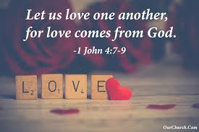
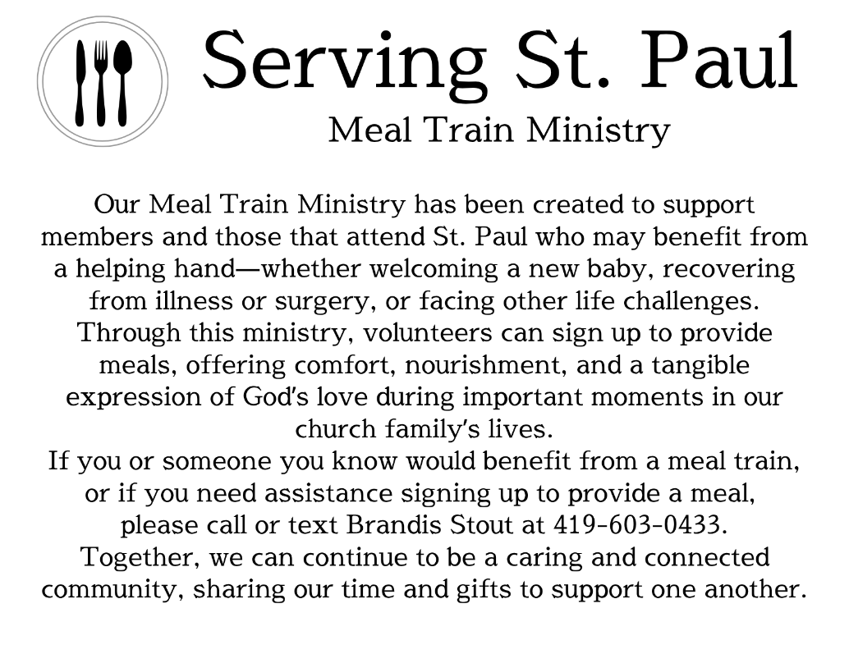
* * * * * * * * * * * * * * * * * * * * * * * * * * * * * * * * * * * * * * * * *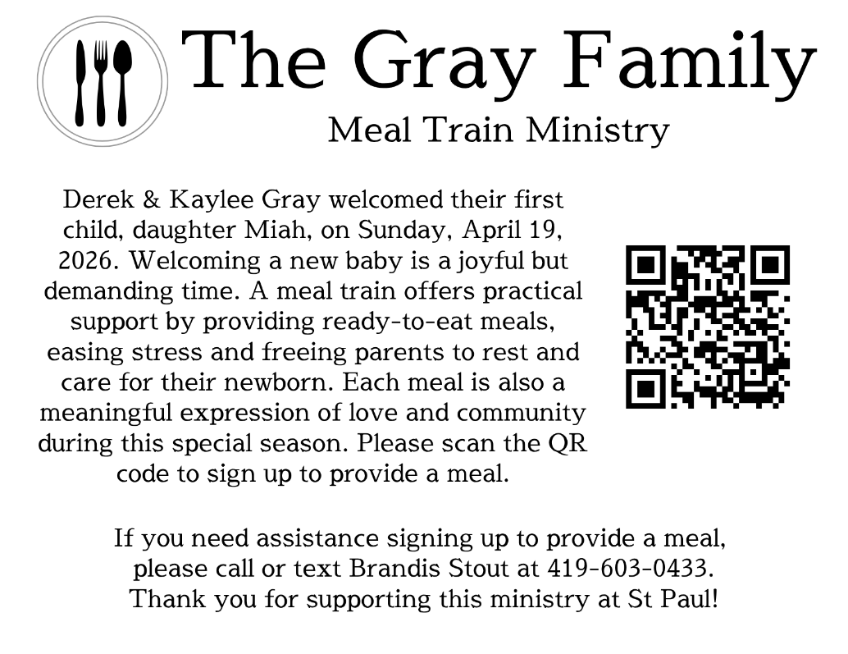May 10, 2026 – May 17, 2026
Sunday the 10th | 8:00 am ~ Worship  9:15 am ~ Sunday School  10:30 am ~ Worship & Confirmation
Monday the 11th | 6:30 pm ~ Co-Ed Bible Study
Tuesday the 12th | 6:00 pm ~ Property Board Meeting  6:30pm ~ Men’s Bible Study
Wednesday the 13th | 6:00 pm ~ Women’s Bible Study
Thursday the 14th | 5:00 pm ~ Evangelism/ Social Board Meeting  6:00 pm ~ Worship Board Meeting  7:00 pm ~ Al-Anon Meeting  8:00 pm ~ AA Meeting
Friday the 15th
Saturday the 16th | 8:00 am ~ Men’s Bible Study  12:00 pm ~ Naomi Conley’s Celebration of Life  5:00 pm ~ Worship
Sunday the 17th | 8:00 am ~ Worship  9:15 am ~ Last Day of Sunday School  10:30 am ~ Worship

Attendance for May 2-3, 2026 ~ 217

8:00 am Service
COMPUTER TECH: Ashley Reed
READER: Diane Hurst
USHERS: Tim Billings
Jeff Haughawout
Diane Hurst
Bob Kessler

* * * * * * * * * * * * * * * * * * * * * * * * * * * * * * * * * * * * * * * * * *
Church Office Phone: 419-547-9225
Pastor Samuel Dagg Phone: 567-342-2137
pastor@stpaulclyde.org
Matt Woodland ~ Council President Phone: 419-603-0567
prez@stpaulclyde.org
Sherry Bouyack ~ Clerical Secretary Phone: 419-547-9225
fisec@stpaulclyde.org
Jim Shull ~ Treasurer Phone: 419-355-6499
treas@stpaulclyde.org
Brian Farrar ~ P & W Leader Phone: 419-271-3085
pwl@stpaulclyde.org
Ashley Reed ~ Assistant Secretary Phone: 419-547-9225
asst.sec@stpaulclyde.org
Organist
Mary Ellen Wollenslegel
* * * * * * * * * * * * * * * * * * * * * * * * * * * * * * * * * * * * *

We offer many different ways to donate to St Paul Lutheran Church. The following QR code is the latest way. It can be used to direct you to St. Paul Lutheran Church’s electronic giving sign up page. You can always give using the church envelopes, the link on St Paul’s website at stpaulclyde.org, or donate by texting Donate/Donations to 844-440-0253 as well. Thank you for your continued support!

