Sixth Sunday of Easter
Sunday, May 10, 2026
10:30 am

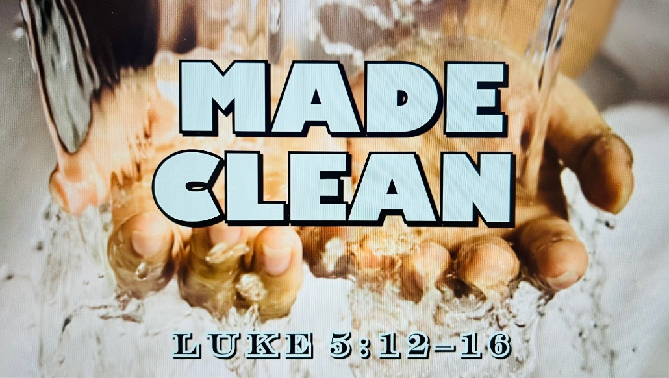

147 West Forest Street Clyde, Ohio
Opening Song
“Good Grace” by Hillsong United
Welcome & Announcements
First Communion
Abigal Lynn Dendinger
Confession & Forgiveness
Worship
“Nothing But the Blood Of Jesus” by Bethel
“Because He Lives” by Celtic Worship
Sermon
"Made Clean"
Luke 5:12-16
Pastor Sam Dagg

Pastoral Prayer
Vickie Aldrich
Gwendolyn Baughn
Michelle Borodkin
Tim Cooper
Toni Dagg
Crew Dearth
Louie Duskin
Sharon Duskin
Pastor Gerry
John Glass
Becky Karr
Kris Larkins
Karen Nimms
Matt Pumphrey
Maverick Salazar
Sue Shull
Lindsay Sooy
Larry Sumner
Conner Whaley
Sandy Wott

Words of Institution
The Lord's prayer
Communion
(Song: “Clean” by Hillsong)
Closing Song
“Reckless Love” by Cory Asbury
Benediction
Dismissal
P: Go in peace. Serve the Lord!
C: Thanks be to God!

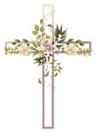
* * * * * * * * * * * * * * * * * * * * * * * * * * * * * * * * * * * * * * * * * *
THE ALTAR FLOWERS are given to the glory of God from The Cross of Lilies Fund.


* * * * * * * * * * * * * * * * * * * * * * * * * * * * * * * * * * * * * * * * *

For Naomi Conley will be held Saturday, May 16, 2026. Graveside Service at 11am ~ McPherson Cemetery and
a luncheon at Noon ~ Parish Hall.

* * * * * * * * * * * * * * * * * * * * * * * * * * * * * * * * * * * * * * * * * *
The Love Packages deadline has been extended to June 1, 2026.
There are bins in the Parish Hall to put your items in.
Any questions contact DeAnn Krauss 419-937-7514.
Their website is lovepackages.org if you’d like to check it out.
* * * * * * * * * * * * * * * * * * * * * * * * * * * * * * * * * * * * * * * * * *
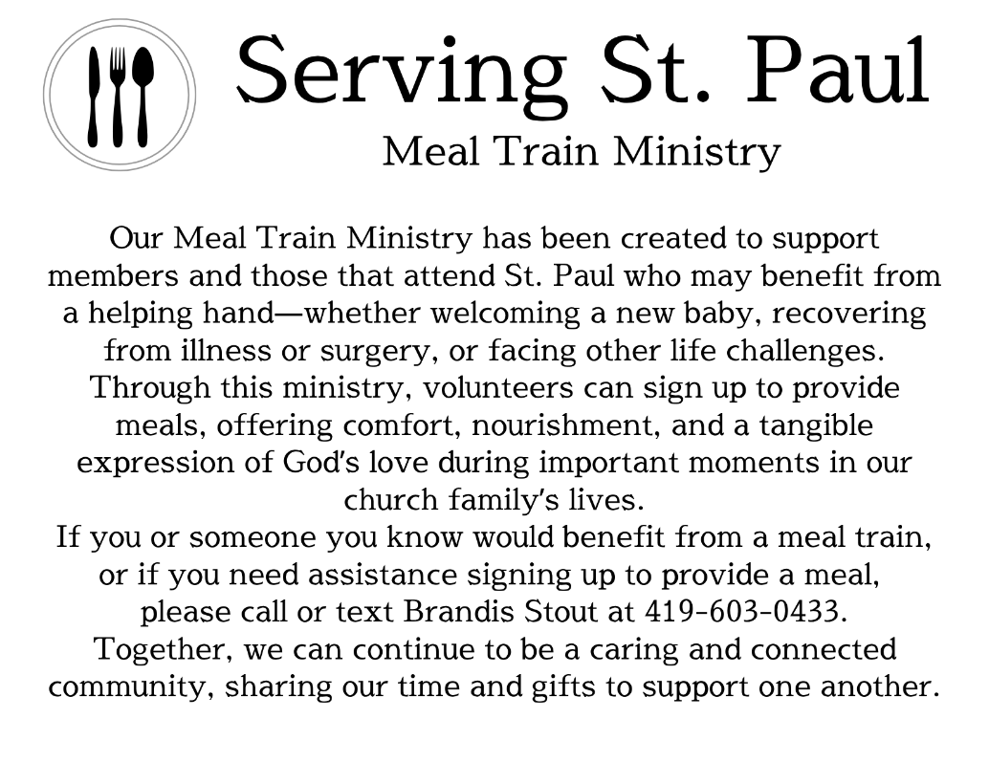
* * * * * * * * * * * * * * * * * * * * * * * * * * * * * * * * * * * * * * * * *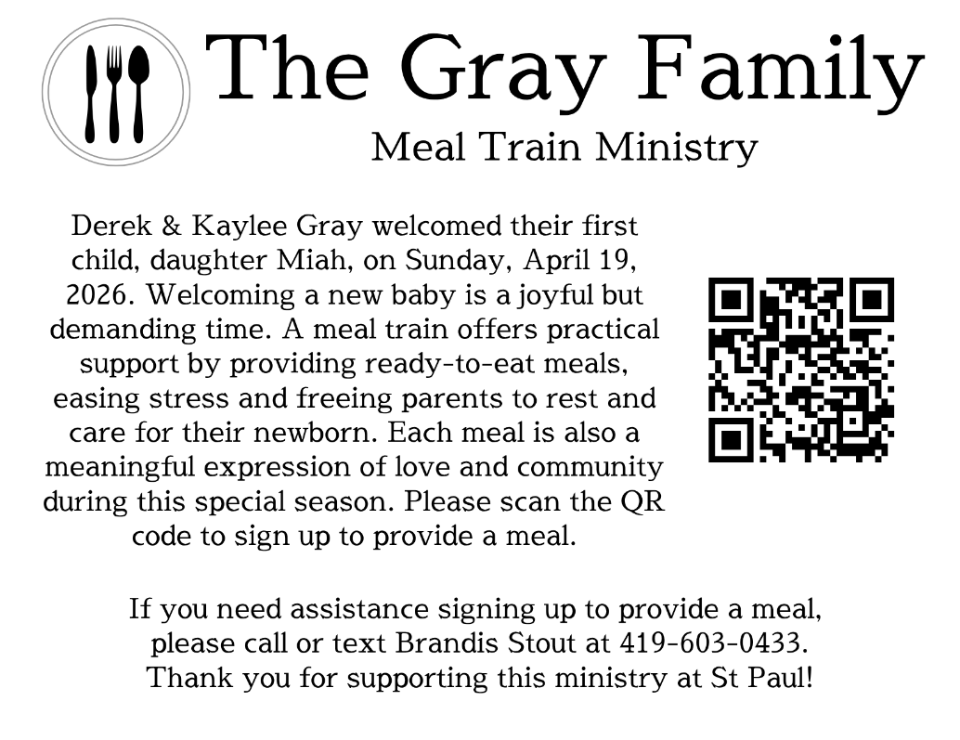May 10, 2026 – May 17, 2026
Sunday the 10th | 8:00 am ~ Worship  9:15 am ~ Sunday School  10:30 am ~ Worship & Confirmation
Monday the 11th | 6:30 pm ~ Co-Ed Bible Study
Tuesday the 12th | 6:00 pm ~ Property Board Meeting  6:30pm ~ Men’s Bible Study
Wednesday the 13th | 6:00 pm ~ Women’s Bible Study
Thursday the 14th | 5:00 pm ~ Evangelism/ Social Board Meeting  6:00 pm ~ Worship Board Meeting  7:00 pm ~ Al-Anon Meeting  8:00 pm ~ AA Meeting
Friday the 15th
Saturday the 16th | 8:00 am ~ Men’s Bible Study  12:00 pm ~ Naomi Conley’s Celebration of Life  5:00 pm ~ Worship
Sunday the 17th | 8:00 am ~ Worship  9:15 am ~ Last Day of Sunday School  10:30 am ~ Worship

Attendance for May 2-3, 2026 ~ 217

10:30 am Service
ACOLYTE: Zaiden Stacy
Blake Williams
USHERS: Steve Jess
Jim Shull
Christina Lowe
Ada Williams
COUNTERS: Theresa Elfring
Christine Potts
Brandis Stout
NURSERY WORKER: Lisa Rieman
* * * * * * * * * * * * * * * * * * * * * * * * * * * * * * * * * * * *
Church Office Phone: 419-547-9225
Pastor Samuel Dagg Phone: 567-342-2137
pastor@stpaulclyde.org
Matt Woodland ~ Council President Phone: 419-603-0567
prez@stpaulclyde.org
Sherry Bouyack ~ Clerical Secretary Phone: 419-547-9225
fisec@stpaulclyde.org
Jim Shull ~ Treasurer Phone: 419-355-6499
treas@stpaulclyde.org
Brian Farrar ~ P & W Leader Phone: 419-271-3085
pwl@stpaulclyde.org
Ashley Reed ~ Assistant Secretary Phone: 419-547-9225 asst.sec@stpaulclyde.org
* * * * * * * * * * * * * * * * * * * * * * * * * * * * * * * * * * * * * * * * * * * * * * * * * * *


We offer many ways to donate to St Paul Lutheran Church. The above QR code is the latest way. It can be used to direct you to St. Paul Lutheran Church’s electronic giving sign up page. You can always give using the church envelopes, the link on St Paul’s website at stpaulclyde.org, or donate by texting Donate/Donations to 844-440-0253 as well. Thank you for your continued support!

