Fifth Sunday in Lent
Sunday, March 22, 2026
8:00 am



147 W. Forest Street Clyde, Ohio
Prelude, Bell & Announcements
Confession & Forgiveness Pg. 94
P: In the name of the Father, and of the ☩ Son, and of the Holy Spirit.
C: Amen.
P: God of all mercy and consolation, come to the help of your people, turning us from our sin to live for you alone. Give us the power of your Holy Spirit that we may confess our sin, receive your forgiveness and grow into the fullness of Jesus Christ, our Savior and Lord.
C: Amen.
P: Let us confess our sin in the presence of God and of one another.
P: Most merciful God,
C: we confess that we are captive to sin and cannot free ourselves. We have sinned against you in thought, word, and deed, by what we have done and by what we have left undone. We have not loved you with our whole heart; we have not loved our neighbors as ourselves. For the sake of your Son, Jesus Christ, have mercy on us. Forgive us, renew us, and lead us, so that we may delight in your will and walk in your ways, to the glory of your holy name. Amen.
P: God who is rich in mercy, loved us even when we were dead in sin, and made us alive together with Christ. By grace you have been saved. In the name of Jesus Christ, the entirety of your sins are forgiven. Almighty God strengthen you by His Holy Spirit that you may live in faith and walk in His ways.
C: Amen.

Hymn “In The Garden” CCLI #62858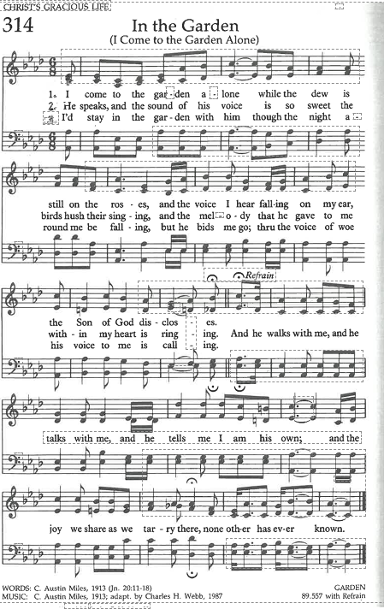The Apostolic Greeting Pg. 147
P: The grace of our Lord Jesus Christ, the love of God, and the communion of the Holy Spirit be with you all.
C: And also with you.
The Kyrie Pg. 147
P: In peace, let us pray to the Lord.
C: Lord, have mercy.
P: For the peace from above, and for our salvation, let us pray to the Lord.
C: Lord, have mercy.
P: For the peace of the whole world, for the well-being of the church of God, and for the unity of all, let us pray to the Lord.
C: Lord, have mercy.
P: For this holy house, and for all who offer here their worship and praise, let us pray to the Lord.
C: Lord, have mercy.
P: Help, save, comfort, and defend us gracious Lord.
C: Amen.
The Prayer of the Day
Almighty God, look favorably upon your family. Graciously rule our bodies lest we are enticed to love the world, and guard our spirits lest we fail to recognize your love. Grant this, we pray, through Jesus Christ, your Son, our Lord, who lives and reigns with you and the Holy Spirit, one God, now and forever. Amen.
The First Reading: Jeremiah 20:7-9
⁷O Lord, you have deceived me, and I was deceived; you are stronger than I, and you have prevailed. I have become a laughingstock all the day; everyone mocks me. ⁸For whenever I speak, I cry out, I shout, “Violence and destruction!” For the word of the Lord has become for me a reproach and derision all day long. ⁹If I say, “I will not mention him, or speak any more in his name,” there is in my heart as it were a burning fire shut up in my bones, and I am weary with holding it in, and I cannot.
L: The Word of the Lord.
C: Thanks be to God.
Psalm 63:1-8
¹O God, you are my God; earnestly I seek you; my soul thirsts for you; my flesh faints for you, as in a dry and weary land where there is no water.
²So I have looked upon you in the sanctuary, beholding your power and glory.
³Because your steadfast love is better than life, my lips will praise you.
⁴So I will bless you as long as I live; in your name I will lift up my hands.
⁵My soul will be satisfied as with fat and rich food, and my mouth will praise you with joyful lips,
⁶when I remember you upon my bed, and meditate on you in the watches of the night;
⁷for you have been my help, and in the shadow of your wings I will sing for joy.
⁸My soul clings to you; your right hand upholds me.
L: Here ends the reading of the Psalm.
C: Thanks be to God.
The Second Reading: Philippians 3:7-11
⁷But whatever gain I had, I counted as loss for the sake of Christ. ⁸Indeed, I count everything as loss because of the surpassing worth of knowing Christ Jesus my Lord. For his sake I have suffered the loss of all things and count them as rubbish, in order that I may gain Christ ⁹and be found in him, not having a righteousness of my own that comes from the law, but that which comes through faith in Christ, the righteousness from God that depends on faith— ¹⁰that I may know him and the power of his resurrection, and may share his sufferings, becoming like him in his death, ¹¹that by any means possible I may attain the resurrection from the dead.
L: The Word of the Lord.
C: Thanks be to God.
The Gospel Acclamation Pg. 151
C: Return to the Lord, your God, for he is gracious and merciful, slow to anger, and abounding in steadfast love.
P: The Holy Gospel according to St. Luke, the 9th chapter.
C: Glory to You, O Lord.
The Gospel: Luke 9:18-25
¹⁸ Now it happened that as he was praying alone, the disciples were with him. And he asked them, “Who do the crowds say that I am?” ¹⁹And they answered, “John the Baptist. But others say, Elijah, and others, that one of the prophets of old has risen.” ²⁰Then he said to them, “But who do you say that I am?” And Peter answered, “The Christ of God.” ²¹ And he strictly charged and commanded them to tell this to no one, ²²saying, “The Son of Man must suffer many things and be rejected by the elders and chief priests and scribes, and be killed, and on the third day be raised.” ²³And he said to all, “If anyone would come after me, let him deny himself and take up his cross daily and follow me. ²⁴For whoever would save his life will lose it, but whoever loses his life for my sake will save it. ²⁵For what does it profit a man if he gains the whole world and loses or forfeits himself?
P: The Gospel of the Lord.
C: Praise to You, O Christ.
Sermon
“The Cost of Following Jesus”
Luke 9:18-25
Pastor Sam Dagg
The Hymn “Where He Leads Me I Will Follow” CCLI #36767
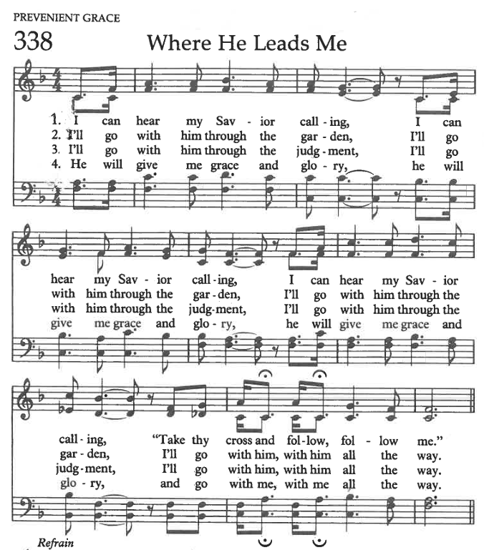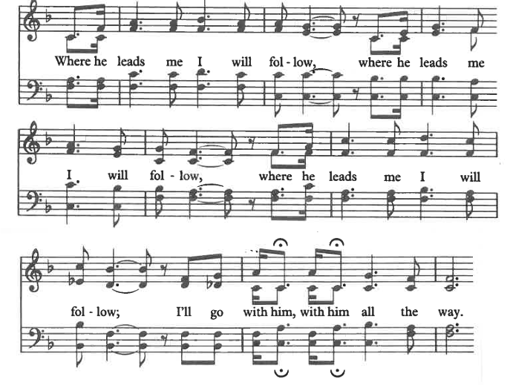
Prayers of Intercession

Patsy Aldrich
Vickie Aldrich
Betsy Anstead
Gwendolyn Baughn
Michelle Borodkin
Tim Cooper
Toni Dagg
Crew Dearth
John Glass
Steve Jess
Maddie Harrell
Cole McBroom
Tanner Misey
Karen Nimms
Maverick Salazar
Sue Shull
Lindsay Sooy
Conner Whaley
Stephanie Wodrich
Sandy Wott

THE APOSTLES’ CREED (back cover of the hymnal)
The Peace of the Lord Pg. 152
P: The peace of the Lord be with you.
C: And also, with you.
The Passing of the Peace
The Offering
The Offering Prayer
Blessed are you, O God, maker of all things. Through your goodness you have blessed us with these gifts: our possessions. Use us, and what we have gathered, in feeding the world with your love, through the one who gave himself for us, Jesus Christ, our Savior and Lord. Amen.
The Great Thanksgiving Pg. 152
P: The Lord be with you.
C: And also, with you.
P: Lift up your hearts.
C: We lift them to the Lord.
P: Let us give thanks to the Lord our God.
C: It is right to give our thanks and praise.
The Proper Preface
P: It is indeed right, our duty and our joy, that we should at all times and in all places give thanks and praise to You, almighty and merciful God, through our Savior Jesus Christ. You call your people to cleanse their hearts and prepare with joy for the paschal feast, that, renewed in the gift of baptism, we may come to the fullness of your grace. And so, with all the choirs of angels, with the church on earth and the hosts of heaven, we praise your name and join their unending hymn:
C: Holy, holy, holy Lord,
Lord God of power and might,
heav’n and earth are full of your glory.
Hosanna in the highest.
Blessed is he who comes in the name of the Lord.
Hosanna in the highest.
The Words of Institution
The Lord’s Prayer Pg. 154
P: Gathered into one by the Holy Spirit, let us pray as Jesus taught us.
C: Our Father, Who art in heaven, hallowed be Thy name, Thy kingdom come, Thy will be done, on earth as it is in heaven. Give us this day our daily bread; and forgive us our trespasses, as we forgive those who trespass against us; and lead us not into temptation, but deliver us from evil. For Thine is the kingdom, and the power, and the glory, forever and ever. Amen.
Invitation to Communion Pg. 154
P: Come to the banquet, for all is now ready.
Holy Communion
All baptized believers in Jesus Christ as Lord are invited to receive communion today. Please follow the directions of the ushers. Children who have not yet received their first communion are also invited to come forward, to receive a blessing.
The Post Communion Blessing
P: The body and blood of our Lord Jesus Christ strengthen you and keep you in His grace.
C: Amen.
Prayer After Communion
P: Let us pray.
C: O God, we give You thanks that You have set before us this feast, the body and blood of Your Son. By Your Spirit strengthen us to serve all in need and to give ourselves away as bread for the hungry, through Jesus Christ our Lord. Amen.
The Hymn “Will You come and Follow Me” #798
The Benediction
Numbers 6:24-26
“The Lord bless you and keep you;
the Lord make his face to shine upon you and be gracious to you; the Lord lift up his countenance upon you and give you peace.”
The Dismissal
P: GO IN PEACE. SERVE THE LORD!
C: Thanks be to God.
The Postlude
* * * * * * * * * * * * * * * * * * * * * * * * * * * * * * * * * * * * * * * * * *

THE ALTAR FLOWERS are given to the Glory of God in memory of my loving husband, Todd, given by Tammy Baker.

* * * * * * * * * * * * * * * * * * * * * * * * * * * * * * * * * * * * * * * * * *
Congrats to the St. Paul dartball team. They took first place by defeating St. John’s, Fremont and then Zion, Gibsonburg. Wishing them good luck in the tournament this Sunday.
* * * * * * * * * * * * * * * * * * * * * * * * * * * * * * * * * * * * * * * * * *

We have received an email from Thrivent to remind members with accounts to designate their Thrivent Choice Dollars to a charity by March 31st.
THANK YOU to all those Thrivent members who have already designated funds to St. Paul.
* * * * * * * * * * * * * * * * * * * * * * * * * * * * * * * * * * * * * * *


The Easter frozen soup and bake sale is coming up on April 4 and 5. St. Paul Women are asking for donations of baked goods and frozen soup. There are soup containers on the back kitchen counter. If you could label what kind of soup it is, that would be great! You may put your soup in the freezer that is just outside of the kitchen. Baked goods can be delivered April 3 until 1 p.m., or I will be at the Church April 4 until noon. If you can't donate items, don't forget to hop on over to the Parish Hall to buy some goodies to share! There will be a box on the table for your donations.
Thanks in advance, Branda
Easter Plants and Cross of Lilies Programs
Sincere thanks to our congregation for the generous response to these programs! Due to your generosity, our Sanctuary will be filled with the glory of God’s nature and our Cross will be beautifully decorated with lilies and carnations. Thank you for remembering or honoring your loved ones and friends! In supporting the Cross of Lilies, you not only help defray the cost of the project, but you also help sustain the beautiful live altar flowers that are displayed each week.
We will have 52 spring plants, so we are giving a heads-up to those with spring-time allergies. If you missed our deadline for ordering, you can still bring in a plant of your own or something you purchased locally. Just be sure the church office knows what wording you would like to have in the Easter bulletins. This information should be
received by the church office NO LATER than Friday, March 27th. Bring your plant to the church by Friday, April 3rd, during the business hours of 9AM to 1PM.
Any plants ordered or purchased locally can be picked up after the 10:30 service on Easter. Please take only those that you ordered/brought in. Any remaining after a few days will be planted or delivered to our home-bound.
For the St. Paul Women, Jane Hilton, treasurer, 419-547-7270

Love Offering Collection
We are collecting a “Love Offering” in support of Maverick Salazar who is a member here. Maverick was born with hypoplastic left heart syndrome. His first open heart surgery was at 4 days old, and then 8 months, and then 2 years old. At 8 years old he needed a pacemaker and in 2024 needed surgery to replace it.
He is now 19 years old. In December 2025 he went into atrial fibrillation. After further testing he was told he now needs a combined heart and liver transplant.
Since birth he has been treated at The University of Michigan Hospital and for this transplant was sent for an evaluation to the Cleveland Clinic and is now being scheduled to go to Duke University Hospital in Durham, North Carolina for evaluation, searching for a hospital willing to take on his complex case.
On top of this, he just found out that before you can be listed for a heart and liver transplant, he will need his wisdom teeth pulled, which needs completed at U of M Hospital because he needs cardiology anesthesia.
All of this means extended travel, long hospital stays, months away from normal life, and ongoing medical expenses before and after surgery.
Our purple “Love Offering” containers will be at each entrance, and we will be collecting through Sunday, April 19th.
Monetary donations are appreciated, but prayer is vital. Please pray for wisdom for the doctors and for God’s strength to surround Maverick and his family.
Thank you,
Blessings!


* * * * * * * * * * * * * * * * * * * * * * * * * * * * * * * * * * * * * * * * *
First Communion & Acolyte Training
First Communion & Acolyte Training will be held on
Saturday, April 18 at 9:00 a.m. & the actual First Communion will be on Sunday, April 19th during the 10:30 service.
The letters for First Communion & Acolyte Training are being sent this week for 4th graders and above.
If you do not receive a letter & you have a child eligible, please contact Ashley in the church office, 419-547-9225. Deadline for a response will be Friday, April 10.
Office hours are Wednesday-Friday from 8am-1pm
OUR LAST WEDNESDAY EVENING SERVICES @ 7:00 pm
March 25 ~ “Return to Hope”
* * * * * * * * * * * * * * * * * * * * * * * * * * * * * * * * * * * * * * * * *
Holy Week Services @ 7:00 pm
April 2 ~ Maundy Thursday
April 3 ~ Good Friday
* * * * * * * * * * * * * * * * * * * * * * * * * * * * * * * * * * * * * * * * *
Lenten Lunch 2026 Schedule
Lunches are held at First United Methodist Church at 12 pm.
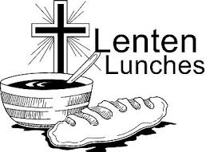
March 25 Lunch by Clyde Christian Church
April 3 ~ No Lunch~ Service at FUMC of Green Springs
* * * * * * * * * * * * * * * * * * * * * * * * * * * * * * * * * * * * * * * * *


March 22, 2026– March 29, 2026
Sunday  the 22nd | 8:00 am ~ Holy Communion Worship  9:15 am ~ Sunday School  10:30 am ~ Holy Communion Worship
Monday  the 23rd | 6:30 pm ~ Co-Ed Bible Study
Tuesday  the 24th | 6:30 pm ~ Men’s Bible Study
Wednesday the 25th | 9:00 am ~ Quilt Ministry  12:00 pm ~ Lenten Luncheon @ FUMC - Clyde  6:00 pm ~ Women’s Bible Study on Pause  Will Resume April 8th  7:00 pm ~ Lenten Service
Thursday the 26th | 7:00 pm ~ Al-Anon Meeting  8:00 pm ~ AA Meeting
Friday
the 27th
Saturday the 28th | 8:00 am ~ Men’s Bible Study  3:00 pm ~ Parish Hall Rental  5:00 pm ~ Holy Communion Worship
Sunday  the 29th | 8:00 am ~ Holy Communion Worship  9:15 am ~ Sunday School  10:30 am ~ Holy Communion Worship
Average Weekly Attendance for February 2026
5 pm ~ 33 8 am ~ 31 10:30 am ~ 101
Financials for January-February 2026
Income ~ $45,915.75
Expenses ~ $53,755.76
Shortage ~ $7,840.01

8:00 am Service
COMPUTER TECH: Barb Wahl
READER: Bev Mendoza
USHERS: Tim Billings
Duane Kimmet
Jeanie Kimmet

* * * * * * * * * * * * * * * * * * * * * * * * * * * * * * * * * * * * * * * * * *
Church Office Phone: 419-547-9225
Pastor Samuel Dagg Phone: 567-342-2137
pastor@stpaulclyde.org
Matt Woodland ~ Council President Phone: 419-603-0567
prez@stpaulclyde.org
Sherry Bouyack ~ Clerical Secretary Phone: 419-547-9225
fisec@stpaulclyde.org
Jim Shull ~ Treasurer Phone: 419-355-6499
treas@stpaulclyde.org
Brian Farrar ~ P & W Leader Phone: 419-271-3085
pwl@stpaulclyde.org
Ashley Reed ~ Assistant Secretary Phone: 419-547-9225
asst.sec@stpaulclyde.org
Organist
Mary Ellen Wollenslegel
* * * * * * * * * * * * * * * * * * * * * * * * * * * * * * * * * * * * *

We offer many different ways to donate to St Paul Lutheran Church. The following QR code is the latest way. It can be used to direct you to St. Paul Lutheran Church’s electronic giving sign up page. You can always give using the church envelopes, the link on St Paul’s website at stpaulclyde.org, or donate by texting Donate/Donations to 844-440-0253 as well. Thank you for your continued support!

