Third Sunday after Epiphany
Sunday, January 25, 2026
8:00 am

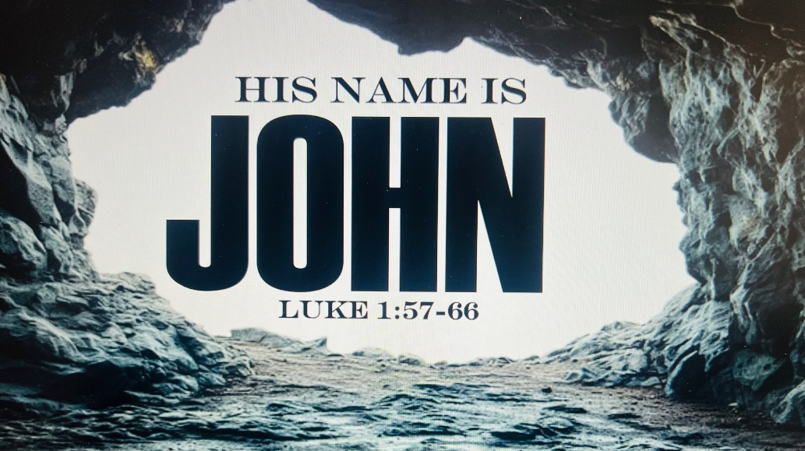

147 W. Forest Street Clyde, Ohio
Prelude
Bell & Announcements
Confession & Forgiveness Pg. 94
P: In the name of the Father, and of the ☩ Son, and of the Holy Spirit.
C: Amen.
P: God of all mercy and consolation, come to the help of your people, turning us from our sin to live for you alone. Give us the power of your Holy Spirit that we may confess our sin, receive your forgiveness and grow into the fullness of Jesus Christ, our Savior and Lord.
C: Amen.
P: Let us confess our sin in the presence of God and of one another.
P: Most merciful God,
C: we confess that we are captive to sin and cannot free ourselves. We have sinned against you in thought, word, and deed, by what we have done and by what we have left undone. We have not loved you with our whole heart; we have not loved our neighbors as ourselves. For the sake of your Son, Jesus Christ, have mercy on us. Forgive us, renew us, and lead us, so that we may delight in your will and walk in your ways, to the glory of your holy name. Amen.
P: God who is rich in mercy, loved us even when we were dead in sin, and made us alive together with Christ. By grace you have been saved. In the name of Jesus Christ, the entirety of your sins are forgiven. Almighty God strengthen you with power through the Holy Spirit, that Christ may live in your hearts through faith.
C: Amen.
Hymn “Precious Lord Take My Hand” #773
The Apostolic Greeting Pg. 147
P: The grace of our Lord Jesus Christ, the love of God, and the communion of the Holy Spirit be with you all.
C: And also with you.
The Kyrie Pg. 147
P: In peace, let us pray to the Lord.
C: Lord, have mercy.
P: For the peace from above, and for our salvation, let us pray to the Lord.
C: Lord, have mercy.
P: For the peace of the whole world, for the well-being of the church of God, and for the unity of all, let us pray to the Lord.
C: Lord, have mercy.
P: For this holy house, and for all who offer here their worship and praise, let us pray to the Lord.
C: Lord, have mercy.
P: Help, save, comfort, and defend us gracious Lord.
C: Amen.
The Hymn of Praise Pg. 149
P: This is the feast of victory for our God. Alleluia.
Worthy is Christ, the Lamb who was slain, whose blood set us free to be people of God. Power and riches and wisdom and strength, and honor and blessing and glory are his.
This is the feast of victory for our God. Alleluia.

Sing with all the people of God and join in the hymn of all creation: Blessing and honor and glory and might be to God and the Lamb forever. Amen.
This is the feast of victory for our God, for the Lamb who was slain has begun his reign. Alleluia. Alleluia.
The Prayer of the Day
Almighty and eternal God, graciously look down on our weakness. Reach out to us with your majestic right hand, and satisfy us with his glory. We ask through the same Jesus Christ, your Son, our Lord, who lives and reigns with you and the Holy Spirit, one God, now and forever. Amen.
The First Reading: Malachi 3:1-4
¹“Behold, I send my messenger, and he will prepare the way before me. And the Lord whom you seek will suddenly come to his temple; and the messenger of the covenant in whom you delight, behold, he is coming, says the Lord of hosts. ²But who can endure the day of his coming, and who can stand when he appears? For he is like a refiner’s fire and like fullers’ soap. ³He will sit as a refiner and purifier of silver, and he will purify the sons of Levi and refine them like gold and silver, and they will bring offerings in righteousness to the Lord. ⁴Then the offering of Judah and Jerusalem will be pleasing to the Lord as in the days of old and as in former years.
L: The Word of the Lord.
C: Thanks be to God.
Psalm 40:6-10
⁶ In sacrifice and offering you have not delighted, but you have given me an open ear. Burnt offering and sin offering you have not required.
⁷Then I said, “Behold, I have come; in the scroll of the book it is written of me:
⁸ I delight to do your will, O my God; your law is within my heart.”
⁹I have told the glad news of deliverance in the great congregation; behold, I have not restrained my lips, as you know, O Lord.
¹⁰I have not hidden your deliverance within my heart; I have spoken of your faithfulness and your salvation; I have not concealed your steadfast love and your faithfulness from the great congregation.
L: Here ends the reading of the Psalm.
C: Thanks be to God.
The Second Reading: Romans 10:14-17
¹⁴How then will they call on him in whom they have not believed? And how are they to believe in him of whom they have never heard? And how are they to hear without someone preaching? ¹⁵And how are they to preach unless they are sent? As it is written, “How beautiful are the feet of those who preach the good news!” ¹⁶But they have not all obeyed the gospel. For Isaiah says, “Lord, who has believed what he has heard from us?” ¹⁷So faith comes from hearing, and hearing through the word of Christ.
L: The Word of the Lord.
C: Thanks be to God.
The Gospel Acclamation Pg. 151
Alleluia. Lord, to whom shall we go? You have the words of eternal life. Alleluia.
P: The Holy Gospel according to St. Luke, the 1st chapter.
C: Glory to You, O Lord.
The Gospel: Luke 1:57-66
⁵⁷Now the time came for Elizabeth to give birth, and she bore a son. ⁵⁸And her neighbors and relatives heard that the Lord had shown great mercy to her, and they rejoiced with her. ⁵⁹And on the eighth day they came to circumcise the child. And they would have called him Zechariah after his father, ⁶⁰but his mother answered, “No; he shall be called John.” ⁶¹And they said to her, “None of your relatives is called by this name.” ⁶²And they made signs to his father, inquiring what he wanted him to be called. ⁶³And he asked for a writing tablet and wrote, “His name is John.” And they all wondered. ⁶⁴And immediately his mouth was opened and his tongue loosed, and he spoke, blessing God. ⁶⁵And fear came on all their neighbors. And all these things were talked about through all the hill country of Judea, ⁶⁶and all who heard them laid them up in their hearts, saying, “What then will this child be?” For the hand of the Lord was with him.
P: The Gospel of the Lord.
C: Praise to You, O Christ.
Sermon
“The Birth of John The Baptist”
Luke 1:57-66
Pastor Sam Dagg
The Hymn “My Faith Look Up To Thee” #759
Prayers of Intercession

Patsy Aldrich
Vickie Aldrich
Todd Baker
Michelle Borodkin
Tim Cooper
Naomi Conley
Toni Dagg
Crew Dearth

Ryker Freeze
Sandy Gray
Bob Royster
Karen Nimms
Maverick Salazar
Lindsay Sooy
Carol Stucky
Conner Whaley
Sandy Wott
THE APOSTLES’ CREED (back cover of the hymnal)
The Peace of the Lord Pg. 152
P: The peace of the Lord be with you.
C: And also, with you.
The Passing of the Peace
The Offering
The Offering Prayer
Blessed are you, O God, maker of all things. Through your goodness you have blessed us with these gifts: our possessions. Use us, and what we have gathered, in feeding the world with your love, through the one who gave himself for us, Jesus Christ, our Savior and Lord. Amen.
The Great Thanksgiving Pg. 152
P: The Lord be with you.
C: And also, with you.
P: Lift up your hearts.
C: We lift them to the Lord.
P: Let us give thanks to the Lord our God.
C: It is right to give our thanks and praise.
The Proper Preface
P: It is indeed right, our duty and our joy, that we should at all times and in all places give thanks and praise to You, almighty and merciful God. You reveal Your glory as the glory of the Father, the Son, and the Holy Spirit; equal in majesty, undivided in splendor, one Lord, one God, ever to be adored in Your eternal glory. And so, with all the choirs of angels, with the church on earth and the hosts of heaven, we praise Your name and join their unending hymn:
C: Holy, holy, holy Lord,
Lord God of power and might,
heav’n and earth are full of your glory.
Hosanna in the highest.
Blessed is he who comes in the name of the Lord.
Hosanna in the highest.
The Words of Institution
The Lord’s Prayer Pg. 154
P: Gathered into one by the Holy Spirit, let us pray as Jesus taught us.
C: Our Father, Who art in heaven, hallowed be Thy name, Thy kingdom come, Thy will be done, on earth as it is in heaven. Give us this day our daily bread; and forgive us our trespasses, as we forgive those who trespass against us; and lead us not into temptation, but deliver us from evil. For Thine is the kingdom, and the power, and the glory, forever and ever. Amen.
Invitation to Communion Pg. 154
P: Come to the banquet, for all is now ready.
Holy Communion
All baptized believers in Jesus Christ as Lord are invited to receive communion today. Please follow the directions of the ushers. Children who have not yet received their first communion are also invited to come forward, to receive a blessing.
The Post Communion Blessing
P: The body and blood of our Lord Jesus Christ strengthen you and keep you in His grace.
C: Amen.
Prayer After Communion
P: Let us pray.
C: O God, we give You thanks that You have set before us this feast, the body and blood of Your Son. By Your Spirit strengthen us to serve all in need and to give ourselves away as bread for the hungry, through Jesus Christ our Lord. Amen.
The Hymn “Will You Come and Follow Me” #798
The Benediction
Acts 20:32a-“And now I commend you to God and to the word of his grace, which is able to build you up”
The Dismissal
P: GO IN PEACE. SERVE THE LORD!
C: Thanks be to God.
The Postlude
* * * * * * * * * * * * * * * * * * * * * * * * * * * * * * * * * * * * * * * * * *

THE ALTAR FLOWERS are given to the glory of God in memory of Jim Billings given by his family.

* * * * * * * * * * * * * * * * * * * * * * * * * * * * * * * * * * * *

Please join us for our Annual Meeting tomorrow after the late service.
* * * * * * * * * * * * * * * * * * * * * * * * * * * * * * * * * * * *
The following items are available for pick up:
- February Reflector
- RightNow Media
- Little Fliers Food Program
- End of Year Statements
- 2026 Envelopes
January 25, 2026 – February 1, 2026
Sunday the 25th | 8:00 am ~ Holy Communion Worship  9:15 am ~ Sunday School  10:30 am ~ Holy Communion Worship  Annual Congregational Meeting and Potluck  3:00 pm ~ BUNCO
Monday the 26th | 6:30 pm ~ Co-Ed Bible Study  7:30 pm ~ Dartball HOME with Grace #24
Tuesday the 27th | 6:30pm ~ Men’s Bible Study
Wednesday the 28th | 9:00 am ~ Quilt Ministry  6:00 pm ~ Women’s Bible Study
Thursday the 29th | 7:00 pm ~ Al-Anon Meeting  8:00 pm ~ AA Meeting
Friday the 30th
Saturday the 31st | 8:00 am ~ Men’s Bible Study  10:00 am ~ Elder Meeting  5:00 pm ~ Holy Communion Worship
Sunday the 1st | 8:00 am ~ Holy Communion Worship  9:15 am ~ Sunday School  9:15 am ~ Women’s Board Meeting  10:30 am ~ Holy Communion Worship  12:00 pm ~ Membership Class
Average Weekly Attendance for December 2025
5 pm ~ 38 8 am ~ 31 10:30 am ~ 88
Financials for 2025
Income ~ $330,302.67
Expenses ~ $319,032.27
Net ~ $11,270.40

8:00 am Service
COMPUTER TECH: Ashley Reed
READER: Bob Jennings
USHERS: Tim Billings
Duane Kimmet
Jeanie Kimmet

* * * * * * * * * * * * * * * * * * * * * * * * * * * * * * * * * * * * *
Pastor Samuel Dagg Phone: 567-342-2137
pastor@stpaulclyde.org
Matt Woodland ~ Council President Phone: 419-603-0567
prez@stpaulclyde.org
Stephanie Stull ~ Office Manager Phone: 419-547-9225
sec@stpaulclyde.org
Sherry Bouyack ~ Clerical Secretary Phone: 419-547-9225
fisec@stpaulclyde.org
Jim Shull ~ Treasurer Phone: 419-355-6499
treas@stpaulclyde.org
Brian Farrar ~ P & W Leader Phone: 419-271-3085
pwl@stpaulclyde.org
Ashley Reed ~ Assistant Secretary Phone: 419-547-9225
asst.sec@stpaulclyde.org
Organist
Mary Ellen Wollenslegel
* * * * * * * * * * * * * * * * * * * * * * * * * * * * * * * * * * * * *

We offer many different ways to donate to St Paul Lutheran Church. The following QR code is the latest way. It can be used to direct you to St. Paul Lutheran Church’s electronic giving sign up page. You can always give using the church envelopes, the link on St Paul’s website at stpaulclyde.org, or donate by texting Donate/Donations to 844-440-0253 as well. Thank you for your continued support!

