Third Sunday after Epiphany
Sunday, January 25, 2026
10:30 am

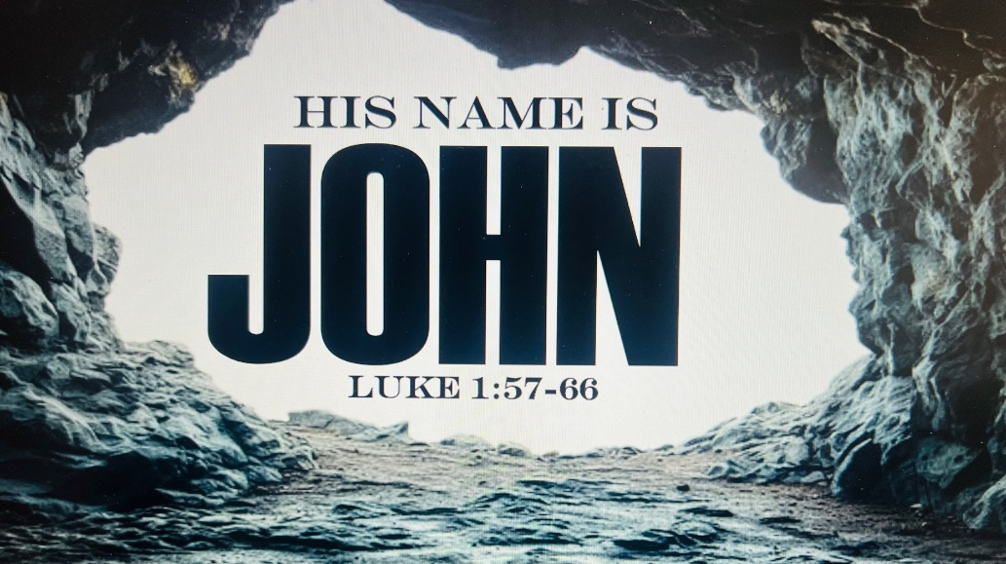

147 W. Forest Street Clyde, Ohio

Opening Song
“That's Who I Praise” by Brandon Lake
Welcome & Announcements
Confession & Forgiveness
Worship
“Rattle” by Elevation Worship
Sermon
“The Birth of John The Baptist”
Luke 1:57-66
Pastor Sam Dagg
Pastoral Prayer

Patsy Aldrich
Vickie Aldrich
Todd Baker
Michelle Borodkin
Tim Cooper
Naomi Conley
Toni Dagg
Crew Dearth
Ryker Freeze
Sandy Gray
Bob Royster
Karen Nimms
Maverick Salazar
Lindsay Sooy
Carol Stucky
Conner Whaley
Sandy Wott
Words of Institution
The Lord's prayer
Communion
"Miricle Child" by Brandon Lake
Closing Song
“In Jesus Name” (God of Possible)
by Katy Nichole
Benediction
Acts 20:32a-“And now I commend you to God and to the word of his grace, which is able to build you up”
Dismissal
P: Go in peace. Serve the Lord!
C: Thanks be to God!

* * * * * * * * * * * * * * * * * * * * * * * * * * * * * * * * *
THE ALTAR FLOWERS are given to the glory of God in memory of Jim Billings given by his family.

* * * * * * * * * * * * * * * * * * * * * * * * * * * * * * * * * * * *

Please join us for our Annual Meeting tomorrow after the late service.
* * * * * * * * * * * * * * * * * * * * * * * * * * * * * * * * * * * *
The following items are available for pick up:

- February Reflector
- RightNow Media
- Little Fliers Food Program
- End of Year Statements
- 2026 Envelopes
January 25, 2026 – February 1, 2026
Sunday the 25th | 8:00 am ~ Holy Communion Worship  9:15 am ~ Sunday School  10:30 am ~ Holy Communion Worship  Annual Congregational Meeting and Potluck  3:00 pm ~ BUNCO
Monday the 26th | 6:30 pm ~ Co-Ed Bible Study  7:30 pm ~ Dartball HOME with Grace #24
Tuesday the 27th | 6:30pm ~ Men’s Bible Study
Wednesday the 28th | 9:00 am ~ Quilt Ministry  6:00 pm ~ Women’s Bible Study
Thursday the 29th | 7:00 pm ~ Al-Anon Meeting  8:00 pm ~ AA Meeting
Friday the 30th
Saturday the 31st | 8:00 am ~ Men’s Bible Study  10:00 am ~ Elder Meeting  5:00 pm ~ Holy Communion Worship
Sunday the 1st | 8:00 am ~ Holy Communion Worship  9:15 am ~ Sunday School  9:15 am ~ Women’s Board Meeting  10:30 am ~ Holy Communion Worship  12:00 pm ~ Membership Class
Average Weekly Attendance for December 2025
5 pm ~ 38 8 am ~ 31 10:30 am ~ 88
Financials for 2025
Income ~ $330,302.67
Expenses ~ $319,032.27
Net ~ $11,270.40
10:30 am Service
ACOLYTE: Madilyn and Abigail Dendinger
USHERS: Steve Jess
Tammy Baker
Dawn Sumner
Kris Wott
COUNTERS: Mel Cook
Karen Jess
NURSERY WORKER: Deanna Turner
* * * * * * * * * * * * * * * * * * * * * * * * * * * * * * *
Pastor Samuel Dagg Phone: 567-342-2137
pastor@stpaulclyde.org
Matt Woodland ~ Council President Phone: 419-603-0567
prez@stpaulclyde.org
Stephanie Stull ~ Office Manager Phone: 419-547-9225
sec@stpaulclyde.org
Sherry Bouyack ~ Clerical Secretary Phone: 419-547-9225
fisec@stpaulclyde.org
Jim Shull ~ Treasurer Phone: 419-355-6499
treas@stpaulclyde.org
Brian Farrar ~ P & W Leader Phone: 419-271-3085
pwl@stpaulclyde.org
Ashley Reed ~ Assistant Secretary Phone: 419-547-9225 asst.sec@stpaulclyde.org
* * * * * * * * * * * * * * * * * * * * * * * * * * * * * * * * * * * * * * * * * * * * * * * * * * *


We offer many different ways to donate to St Paul Lutheran Church. The following QR code is the latest way. It can be used to direct you to St. Paul Lutheran Church’s electronic giving sign up page. You can always give using the church envelopes, the link on St Paul’s website at stpaulclyde.org, or donate by texting Donate/Donations to 844-440-0253 as well. Thank you for your continued support!

