19th Sunday After Pentecost
Sunday October 4, 2026
10:30 am

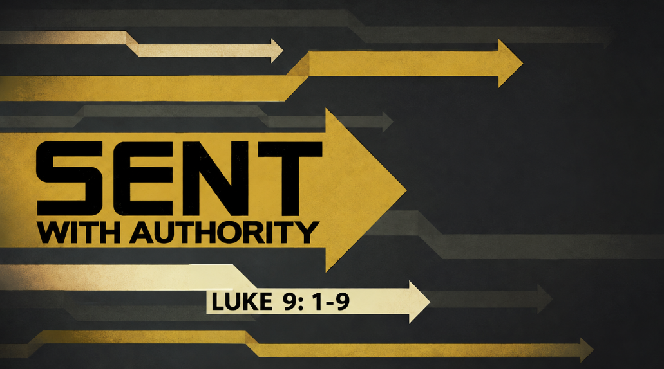

147 West Forest Street Clyde, Ohio

Prayer List
Vickie Aldrich
Gwendolyn Baughn
Molly Binder
Michelle Borodkin
Courtney Bouyack
Tim Cooper
Toni Dagg
Crew Dearth
Sharon Duskin
Becky Karr
Kris Larkins
Denise McCubbin
Matt Pumphrey
Maverick Salazar
Lindsay Sooy
Larry Sumner
Conner Whaley
Sandy Wott
Dean Tea
Matt Woodland
Terry Langham
Judy Campbell
Carolyn Bannister
Ken Stucky
Dot Mowry

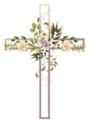
* * * * * * * * * * * * * * * * * * * * * * * * * * * * * * * * * * * * * * * * * *
ALTAR FLOWERS


The altar flowers are given to the Glory of God in honor of Tom and Linda Thorbahn’s 50th wedding anniversary October 8th.
* * * * * * * * * * * * * * * * * * * * * * * * * * * * * * * * *



Anyone interested in being a player on the church dart ball team this year is welcome to come and enjoy the fun and fellowship! Practice is on Monday Oct. 5 @ 7:00pm. Located in the Parish Hall at St.Paul with dart ball season BEGINNING Monday Oct. 12 @ 7:30pm. Any questions please contact Bob Kessler @ 419-307-4408.
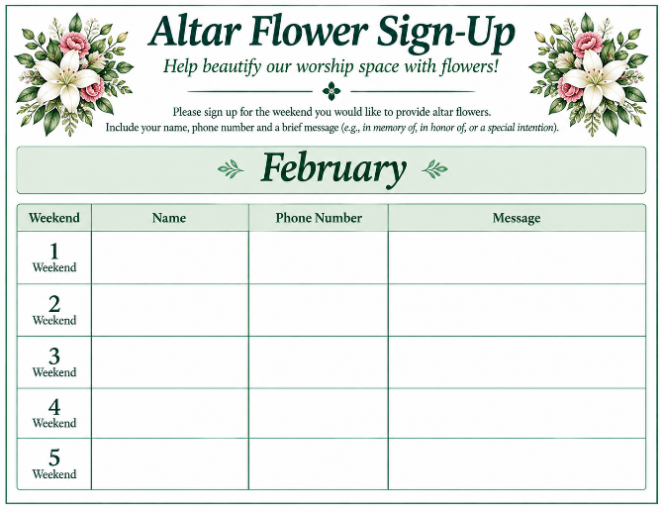
* * * * * * * * * * * * * * * * * * * * * * * * * * * * * * * * * * * * * * * * * * * * * * New Altar Flower Sing-Up 2027
The new altar flower sign-up is located in Ashley’s mailbox by the office. Please fill out all 3 slots and any specific instructions for flowers. Thank you!
-Jamie Farrar
October 2026
Sunday  4 | 8:00 am ~ Worship  10:30 am ~ Worship
Monday  5 | 6:30 pm ~ Co-Ed Bible Study  7:00 pm ~ Dartball Practice
Tuesday  6 | 6:30 pm ~ Men’s Bible Study
Wednesday  7 | 6:00 pm ~ Women’s Bible Study
Thursday  8 | 7:00 pm ~ Al-Anon Meeting  8:00 pm ~ AA Meeting
Friday
9
Saturday  10 | 8:00 am ~ Men’s Bible Study  5:00 pm ~ Worship
Sunday  11 | 8:00 am ~ Worship  10:30 am ~ Worship
September 26-27 Attendance: 170
10:30 Service
ACOLYTE: Ellie Stout
USHERS: Gary Wott
Tom Billings
Keyli Billings
Steve Jess
COUNTERS: Sherry Frasher
Jennie McCoy
Michelle Dagg

Nursery Supervision
Oct. 4th - Tammy Baker

Oct. 11th- Emily Woodland
Oct. 18th – Lisa Rieman

Oct. 25th – Katie Speer

* * * * * * * * * * * * * * * * * * * * * * * * * * * * * * * * * * * *
Church Office Phone: 419-547-9225
Jamie Farrar Phone: 419-603-6731
sec@stpaulclyde.org
Pastor Samuel Dagg Phone: 567-342-2137
pastor@stpaulclyde.org
Matt Woodland ~ Council President Phone: 419-603-0567
prez@stpaulclyde.org
Jim Shull ~ Treasurer Phone: 419-355-6499
treas@stpaulclyde.org
Brian Farrar ~ P & W Leader Phone: 419-547-9225
pwl@stpaulclyde.org
Sherry Bouyack ~ Clerical Secretary fisec@stpaulclyde.org
Sermon Notes

