19th Sunday after Pentecost
Sunday October 4, 2026
8:00 am

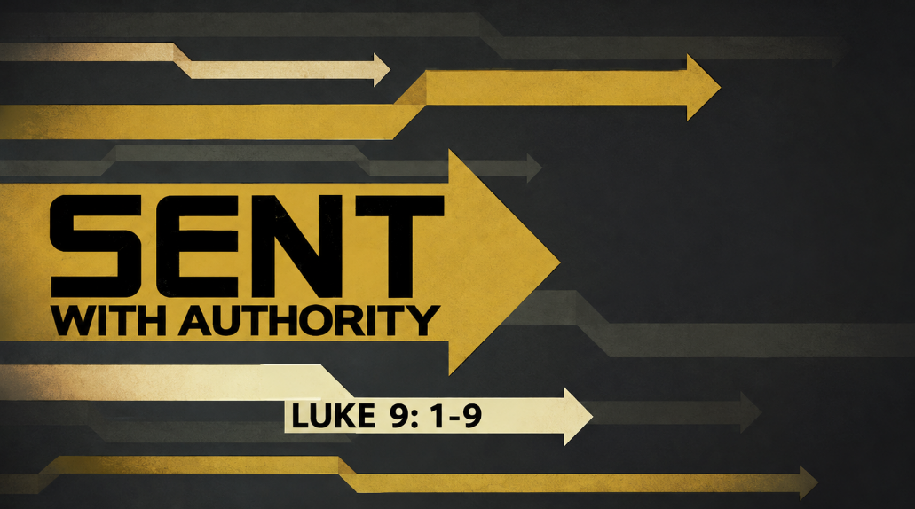

147 West Forest Street Clyde, Ohio
Prelude, Bell & Announcements
Confession & Forgiveness Pg. 94
P: In the name of the Father, and of the ☩ Son, and of the Holy Spirit.
C: Amen.
P: God of all mercy and consolation, come to the help of your people, turning us from our sin to live for you alone. Give us the power of your Holy Spirit that we may confess our sin, receive your forgiveness and grow into the fullness of Jesus Christ, our Savior and Lord.
C: Amen.
P: Let us confess our sin in the presence of God and of one another.
P: Most merciful God,
C: We confess that we are captive to sin and cannot free ourselves. We have sinned against you in thought, word, and deed, by what we have done and by what we have left undone. We have not loved you with our whole heart; we have not loved our neighbors as ourselves. For the sake of your Son, Jesus Christ, have mercy on us. Forgive us, renew us, and lead us, so that we may delight in your will and walk in your ways, to the glory of your holy name. Amen.
P: God who is rich in mercy, loved us even when we were dead in sin, and made us alive together with Christ. By grace you have been saved. In the name of Jesus Christ, the entirety of your sins are forgiven. Almighty God strengthen you with power through the Holy Spirit, that Christ may live in your hearts through faith.
C: Amen.
Hymn “If You but Trust in God to Guide You” 4vs #769

The Apostolic Greeting Pg. 147
P: The grace of our Lord Jesus Christ, the love of God, and the communion of the Holy Spirit be with you all.
C: And also with you.
The Kyrie Pg. 147
P: In peace, let us pray to the Lord.
C: Lord, have mercy.
P: For the peace from above, and for our salvation, let us pray to the Lord.
C: Lord, have mercy.
P: For the peace of the whole world, for the well-being of the church of God, and for the unity of all, let us pray to the Lord.
C: Lord, have mercy.
P: For this holy house, and for all who offer here their worship and praise, let us pray to the Lord.
C: Lord, have mercy.
P: Help, save, comfort, and defend us gracious Lord.
C: Amen.
The Hymn of Praise Pg. 149
P: This is the feast of victory for our God. Alleluia.
Worthy is Christ, the Lamb who was slain, whose blood set us free to be people of God. Power and riches and wisdom and strength, and honor and blessing and glory are his.
This is the feast of victory for our God. Alleluia.
Sing with all the people of God and join in the hymn of all creation: Blessing and honor and glory and might be to God and the Lamb forever. Amen.
This is the feast of victory for our God, for the Lamb who was slain has begun his reign. Alleluia. Alleluia.
The Prayer of the Day
Generously pardon and give peace to your faithful people, O Lord, that being cleansed from every sin, we may be free and glad to serve; through Jesus Christ, your Son, our Lord, who lives and reigns with you and the Holy Spirit, one God, now and forever. Amen.
The First Reading: Jeremiah 1:4–10
⁴Now the word of the Lord came to me, saying, ⁵“Before I formed you in the womb I knew you, and before you were born I consecrated you; I appointed you a prophet to the nations.” ⁶Then I said, “Ah, Lord God! Behold, I do not know how to speak, for I am only a youth.” ⁷But the Lord said to me, “Do not say, ‘I am only a youth’; for to all to whom I send you, you shall go, and whatever I command you, you shall speak. ⁸Do not be afraid of them, for I am with you to deliver you, declares the Lord.” ⁹Then the Lord put out his hand and touched my mouth. And the Lord said to me, “Behold, I have put my words in your mouth. ¹⁰See, I have set you this day over nations and over kingdoms, to pluck up and to break down, to destroy and to overthrow, to build and to plant.”
L: The Word of the Lord.
C: Thanks be to God.
Psalm 96:1-6
¹Oh sing to the Lord a new song; sing to the Lord, all the earth!
²Sing to the Lord, bless his name; tell of his salvation from day to day.
³Declare his glory among the nations, his marvelous works among all the peoples!
⁴For great is the Lord, and greatly to be praised; he is to be feared above all gods.
⁵For all the gods of the peoples are worthless idols, but the Lord made the heavens.
⁶Splendor and majesty are before him; strength and beauty are in his sanctuary.
L: Here ends the reading of the Psalm.
C: Thanks be to God.
The Second Reading: Romans 10:11-17
¹¹For the Scripture says, “Everyone who believes in him will not be put to shame.” ¹²For there is no distinction between Jew and Greek; for the same Lord is Lord of all, bestowing his riches on all who call on him. ¹³For “everyone who calls on the name of the Lord will be saved.” ¹⁴How then will they call on him in whom they have not believed? And how are they to believe in him of whom they have never heard? And how are they to hear without someone preaching? ¹⁵And how are they to preach unless they are sent? As it is written, “How beautiful are the feet of those who preach the good news!” ¹⁶But they have not all obeyed the gospel. For Isaiah says, “Lord, who has believed what he has heard from us?” ¹⁷So faith comes from hearing, and hearing through the word of Christ.
L: The Word of the Lord.
C: Thanks be to God.
The Gospel Acclamation Pg. 151
Alleluia. Lord, to whom shall we go? You have the words of eternal life. Alleluia.
P: The Holy Gospel according to St. Luke, the 9th chapter.
C: Glory to You, O Lord.
The Gospel: Luke 9:1-9
¹And he called the twelve together and gave them power and authority over all demons and to cure diseases, ²and he sent them out to proclaim the kingdom of God and to heal. ³And he said to them, “Take nothing for your journey, no staff, nor bag, nor bread, nor money; and do not have two tunics. ⁴And whatever house you enter, stay there, and from there depart. ⁵And wherever they do not receive you, when you leave that town shake off the dust from your feet as a testimony against them.” ⁶And they departed and went through the villages, preaching the gospel and healing everywhere. Herod Is Perplexed by Jesus ⁷Now Herod the tetrarch heard about all that was happening, and he was perplexed, because it was said by some that John had been raised from the dead, ⁸by some that Elijah had appeared, and by others that one of the prophets of old had risen. ⁹Herod said, “John I beheaded, but who is this about whom I hear such things?” And he sought to see him.
P: Gospel of the Lord
C: Praise to You, O Christ.
Sermon “Sent With Authority”
Luke 9:1-9
Pastor Sam Dagg
The Hymn “I know That My Redeemer Lives” vs 1-4 #619
Prayers of Intercession
Vickie Aldrich
Gwendolyn Baughn
Molly Binder
Michelle Borodkin
Courtney Bouyack
Tim Cooper
Toni Dagg
Crew Dearth
Sharon Duskin
Becky Karr
Kris Larkins
Denise McCubbin
Matt Pumphrey
Maverick Salazar
Lindsay Sooy
Larry Sumner
Conner Whaley
Sandy Wott
Dean Tea
Matt Woodland
Terry Langham
Judy Campbell
Carolyn Bannister
Ken Stucky
Dot Mowry
THE APOSTLES’ CREED (back cover of the hymnal)
The Peace of the Lord Pg. 152
P: The peace of the Lord be with you.
C: And also, with you.
The Passing of the Peace
The Offering
The Offering Prayer
Blessed are you, O God, maker of all things. Through your goodness you have blessed us with these gifts: our possessions. Use us, and what we have gathered, in feeding the world with your love, through the one who gave himself for us, Jesus Christ, our Savior and Lord. Amen.
The Great Thanksgiving Pg. 152
P: The Lord be with you.
C: And also, with you.
P: Lift up your hearts.
C: We lift them to the Lord.
P: Let us give thanks to the Lord our God.
C: It is right to give our thanks and praise.
The Proper Preface
P: It is indeed right, our duty and our joy, that we should at all times and in all places give thanks and praise to You, almighty and merciful God. You reveal Your glory as the glory of the Father, the Son, and the Holy Spirit; equal in majesty, undivided in splendor, one Lord, one God, ever to be adored in Your eternal glory. And so, with all the choirs of angels, with the church on earth and the hosts of heaven, we praise Your name and join their unending hymn:

C: Holy, holy, holy Lord,
Lord God of power and might,
heav’n and earth are full of your glory.
Hosanna in the highest.
Blessed is he who comes in the name of the Lord.
Hosanna in the highest.
The Words of Institution
The Lord’s Prayer Pg. 154
P: Gathered into one by the Holy Spirit, let us pray as Jesus taught us.
C: Our Father, Who art in heaven, hallowed be Thy name, Thy kingdom come, Thy will be done, on earth as it is in heaven. Give us this day our daily bread; and forgive us our trespasses, as we forgive those who trespass against us; and lead us not into temptation, but deliver us from evil. For Thine is the kingdom, and the power, and the glory, forever and ever. Amen.
Invitation to Communion Pg. 154 P: Come to the banquet, for all is now ready.
Holy Communion
All baptized believers in Jesus Christ as Lord are invited to receive communion today. Please follow the pastor’s instructions.
The Post Communion Blessing
P: The body and blood of our Lord Jesus Christ strengthen you and keep you in His grace.
C: Amen.

Prayer After Communion
P: Let us pray.
C: O God, we give You thanks that You have set before us this feast, the body and blood of Your Son. By Your Spirit strengthen us to serve all in need and to give ourselves away as bread for the hungry, through Jesus Christ our Lord. Amen.
The Hymn “Sent Forth by God’s Blessing 2vs #547
The Benediction
P: May the Lord bless you and keep you;
the Lord make his face shine on you and be gracious to you;
the Lord turn his face toward you and give you peace.
In the name of the Father,
and of the ☩ Son,
and of the Holy Spirit.
C: Amen.
The Dismissal
P: GO IN PEACE. SERVE THE LORD!
C: Thanks be to God.
The Postlude

* * * * * * * * * * * * * * * * * * * * * * * * * * * * * * * * * * * * * * * * * *
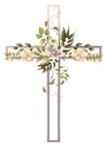
ALTAR FLOWERS
The altar flowers are given to the Glory of God in honor of Tom and Linda Thorbahn’s 50th wedding anniversary October 8th.
* * * * * * * * * * * * * * * * * * * * * * * * * * * * * * * * * * *



Anyone interested in being a player on the church dart ball team this year is welcome to come and enjoy the fun and fellowship! Practice is on Monday Oct. 5 @ 7:00pm. Located in the Parish Hall at St.Paul with dart ball season BEGINNING Monday Oct. 12 @ 7:30pm. Any questions please contact Bob Kessler @ 419-307-4408

* * * * * * * * * * * * * * * * * * * * * * * * * * * * * * * * * * * * * * * * * * New Altar Flower Sing-Up 2027
The new altar flower sign-up is located in Ashley’s mailbox by the office. Please fill out all 3 slots and any specific instructions for flowers. Thank you!
-Jamie Farrar

October 2026
Sunday  4 | 8:00 am ~ Worship  10:30 am ~ Worship
Monday  5 | 6:30 pm ~ Co-Ed Bible Study  7:00 pm ~ Dartball Practice
Tuesday  6 | 6:30 pm ~ Men’s Bible Study
Wednesday  7 | 6:00 pm ~ Women’s Bible Study
Thursday  8 | 7:00 pm ~ Al-Anon Meeting  8:00 pm ~ AA Meeting
Friday
9
Saturday  10 | 8:00 am ~ Men’s Bible Study  5:00 pm ~ Worship
Sunday  11 | 8:00 am ~ Worship  10:30 am ~ Worship
September 26-27 Attendance: 170
8:00 am Service
COMPUTER TECH: Barb Wahl
READER: Ashley Reed
USHERS: Kevin Larkins
Michelle Larkins
Jim Sieger
Brenda Sieger

* * * * * * * * * * * * * * * * * * * * * * * * * * * * * * * * * * * * * * * * *
Church Office Phone: 419-547-9225
Jamie Farrar Phone: 419-603-6731
sec@stpaulclyde.org
Pastor Samuel Dagg Phone: 567-342-2137
pastor@stpaulclyde.org
Matt Woodland ~ Council President Phone: 419-603-0567
prez@stpaulclyde.org
Jim Shull ~ Treasurer Phone: 419-355-6499
treas@stpaulclyde.org
Brian Farrar ~ P & W Leader Phone: 419-547-9225
pwl@stpaulclyde.org
Sherry Bouyack ~ Clerical Secretary fisec@stpaulclyde.org
Organist
Mary Ellen Wollenslegel
* * * * * * * * * * * * * * * * * * * * * * * * * * * * * * * * * * * * *

Sermon Notes

